**DEPLOYING WORDPRESS ON GKE AND CLOUD SQL IN DIFFERENT VPC**

**ON**

**GOOGLE CLOUD PLATFORM**

**G**oogle Cloud Platform(GCP),offered by [Google](https://en.wikipedia.org/wiki/Google), is a suite of [cloud computing](https://en.wikipedia.org/wiki/Cloud_computing) services that runs on the same infrastructure that Google uses internally for its end-user products, such as [Google Search](https://en.wikipedia.org/wiki/Google_Search), [Gmail](https://en.wikipedia.org/wiki/Gmail), [file storage](https://en.wikipedia.org/wiki/Google_Drive), and [YouTube](https://en.wikipedia.org/wiki/YouTube). Alongside a set of management tools, it provides a series of modular cloud services including computing, [data storage](https://en.wikipedia.org/wiki/Computer_data_storage), [data analytics](https://en.wikipedia.org/wiki/Data_analysis), and [machine learning](https://en.wikipedia.org/wiki/Machine_learning). Registration requires a [credit card](https://en.wikipedia.org/wiki/Credit_card) or bank account details. Google Cloud Platform provides [infrastructure as a service](https://en.wikipedia.org/wiki/Infrastructure_as_a_service), [platform as a service](https://en.wikipedia.org/wiki/Platform_as_a_service), and [serverless computing](https://en.wikipedia.org/wiki/Serverless_computing) environments.

|  |
| --- |
| What’s inside? |
| * Multiple projects namely developer and production * VPC network for both the projects * VPC Peering * Kubernetes Cluster in developer project and launch any web application with the Load balancer * SQL Server in the production project and create a database * Connect the SQL database to the web application launched in the Kubernetes cluster |

This project shows you how to set up a WordPress deployment on Google Kubernetes Engine (GKE) using a MySQL database. Instead of installing MySQL, you use Cloud SQL, which provides a managed version of MySQL.

The containers you run on GKE are typically disposable entities, and the cluster manager can delete, evict, or reschedule any containers that become unavailable due to node failures or other causes. When nodes fail, all data saved to a container's root file system is lost.

**CREATE A PROJECTS NAMELY PRODUCTION**

In the Cloud Console, on the project selector page, create a Cloud project named production.

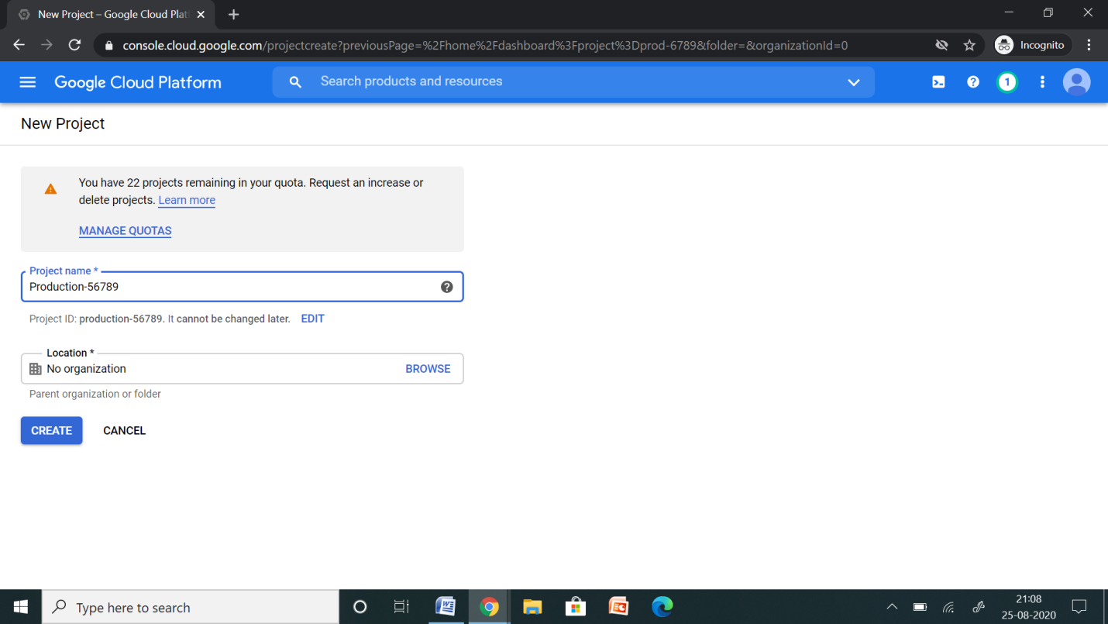

**CREATE A PROJECTS NAMELY DEVELOPER**

In the Cloud Console, on the project selector page, create a Cloud project named developer.

[Activate Cloud Shell](https://console.cloud.google.com/?cloudshell=true): At the bottom of the Cloud Console, a [Cloud Shell](https://cloud.google.com/shell/docs/features) session starts and displays a command-line prompt. Cloud Shell is a shell environment with the Cloud SDK already installed, including the gcloud command-line tool, and with values already set for your current project. It can take a few seconds for the session to initialize.

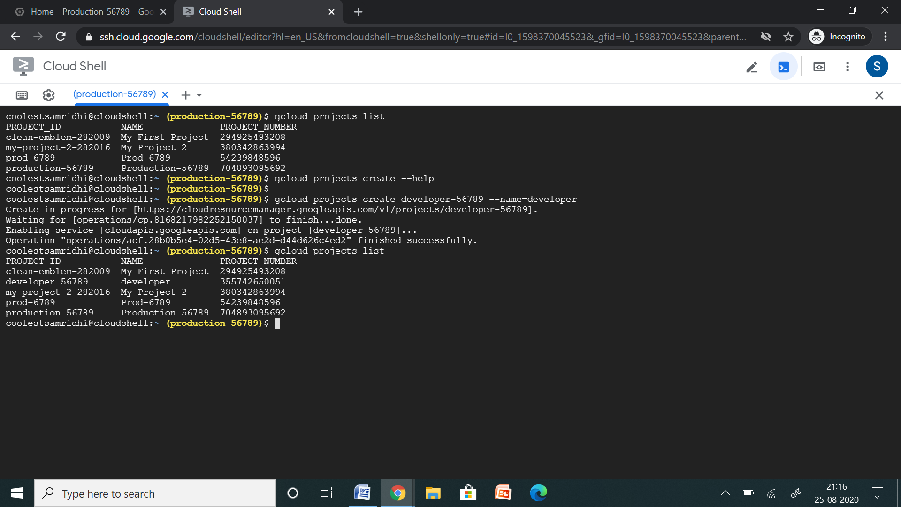

Make sure that billing is enabled for your Google Cloud project.

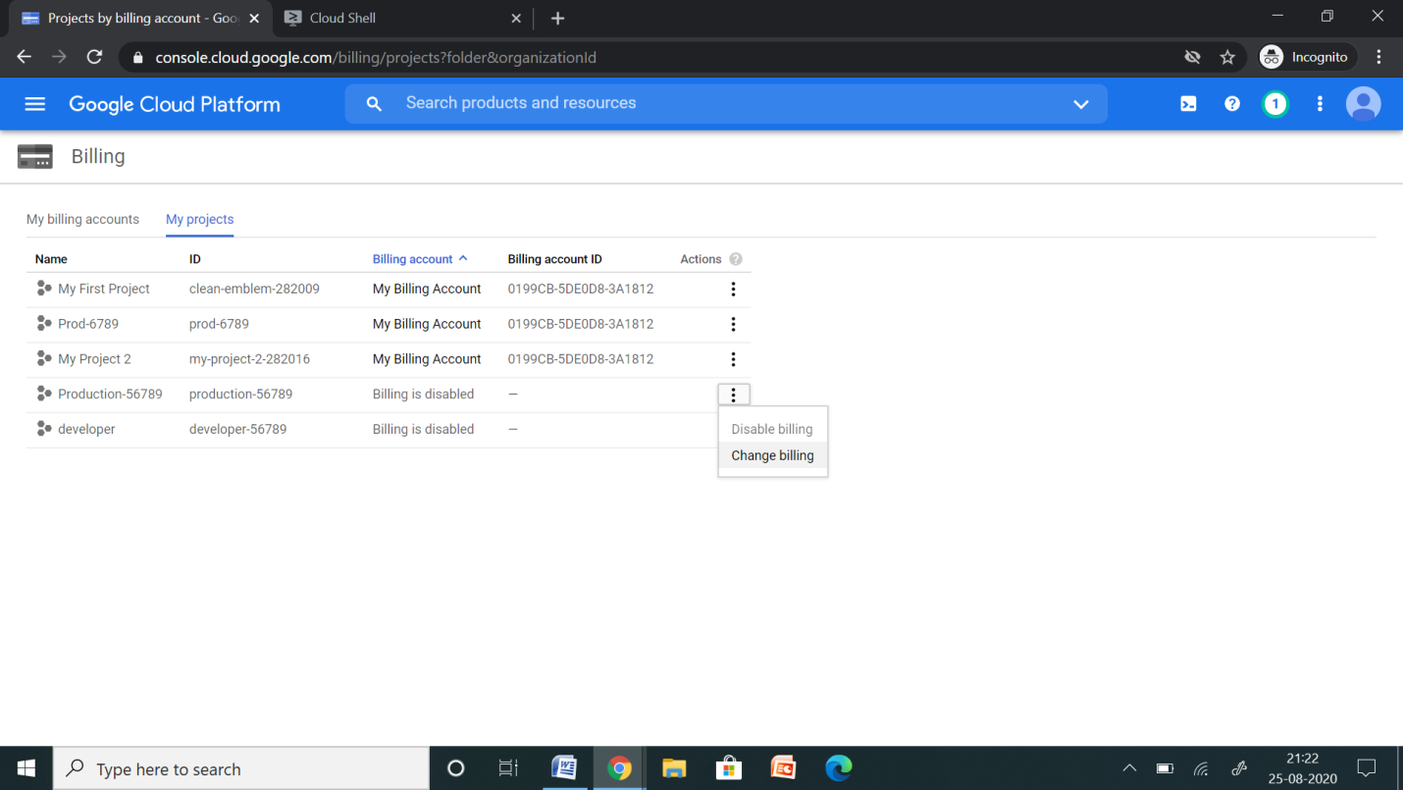

**CREATE VPC FOR DEVELOPER PROJECT**

VPC Network 🡪 Create VPC Network

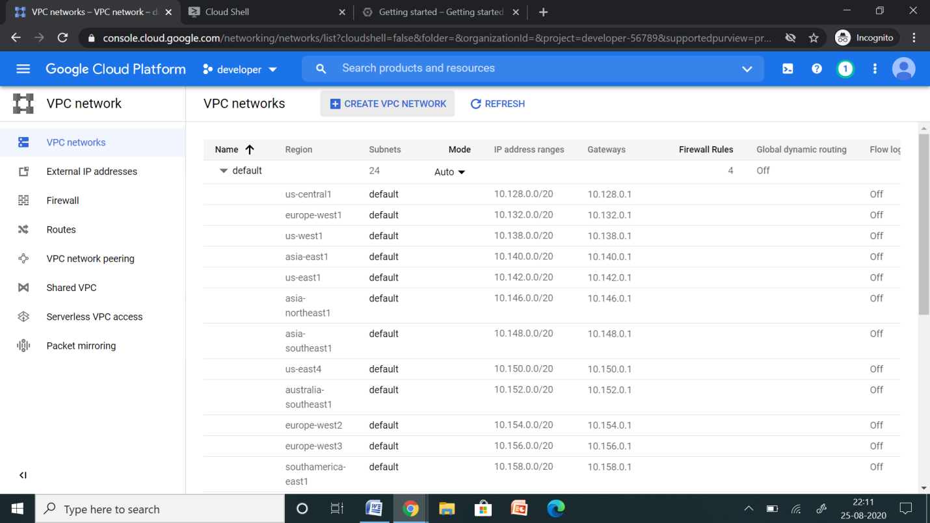

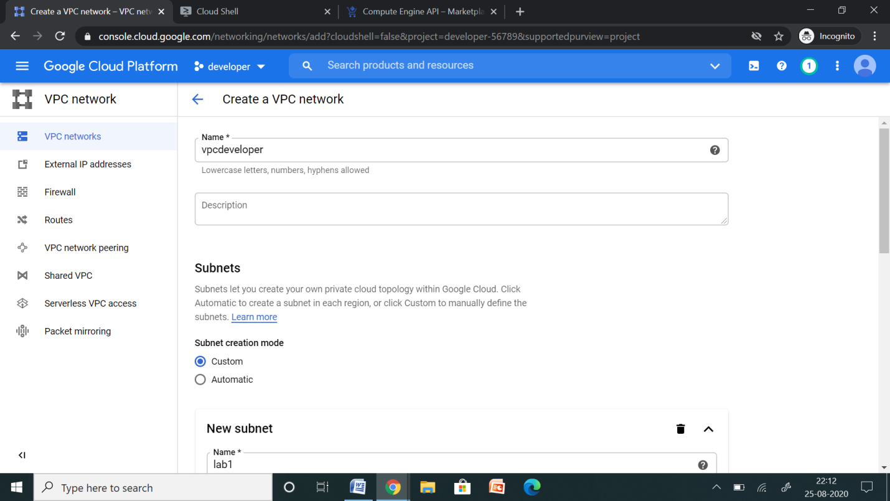

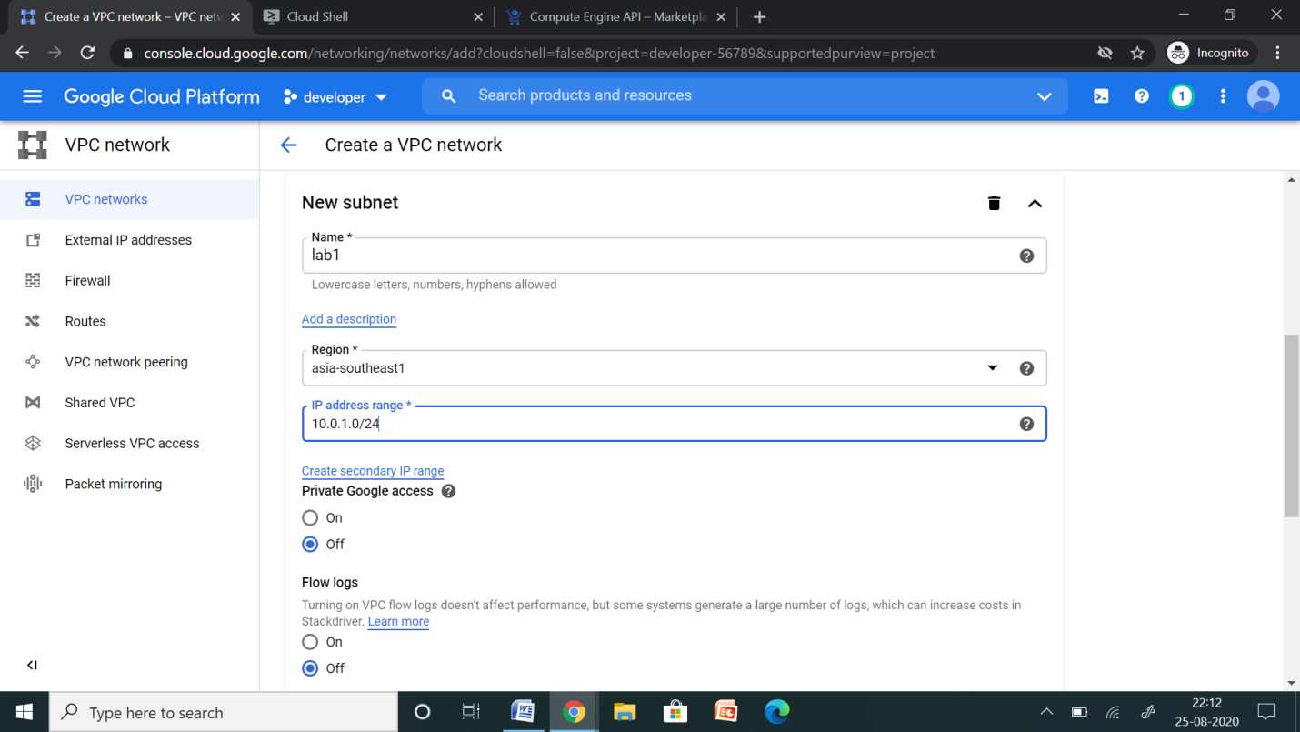

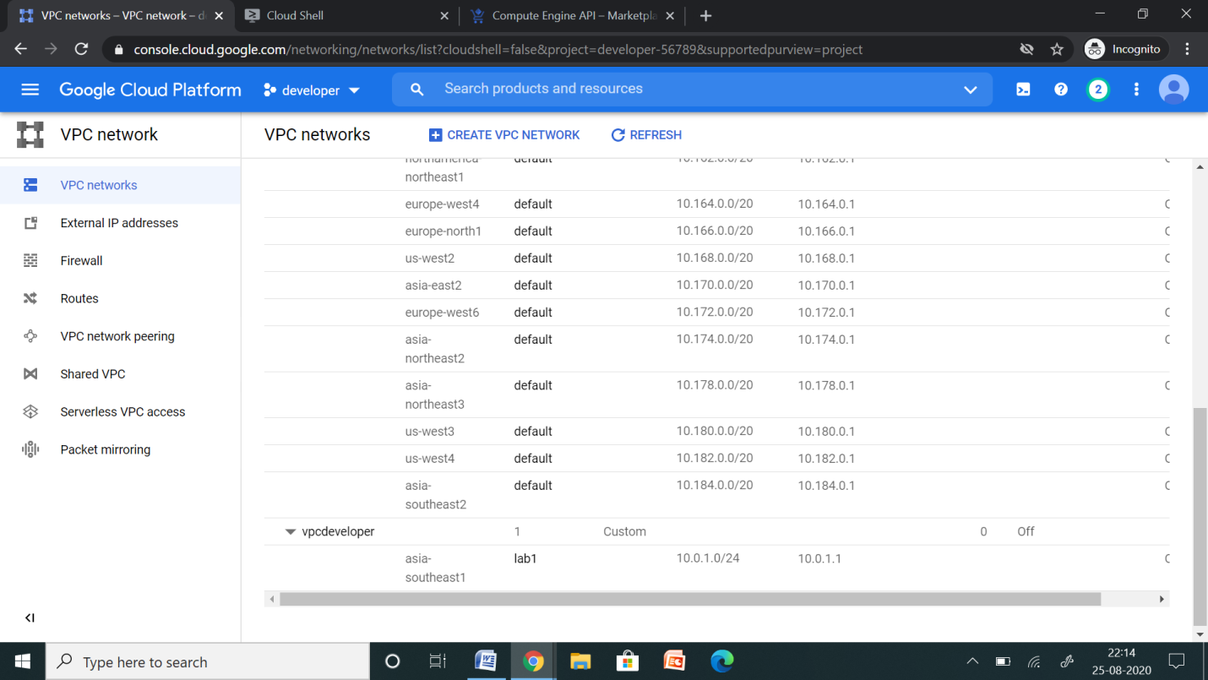

**CREATE VPC FOR PRODUCTION PROJECT**

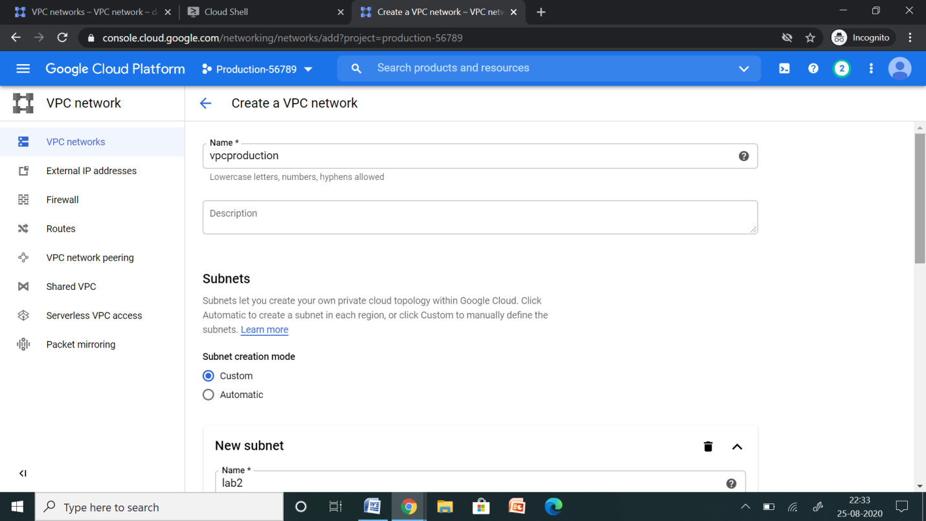

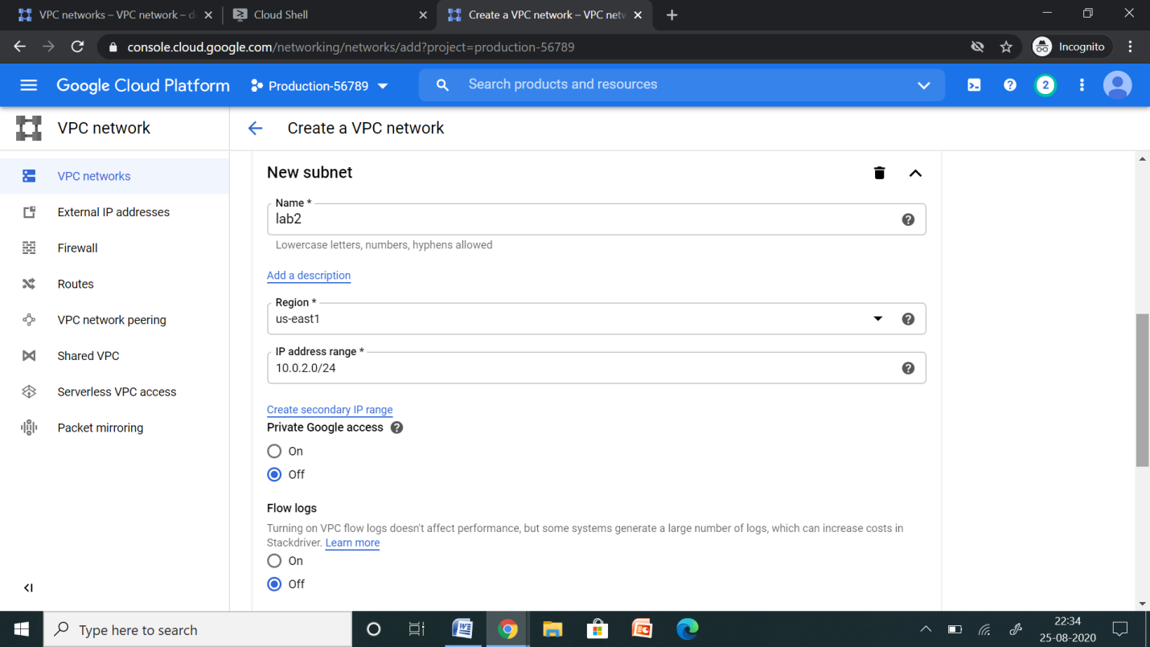

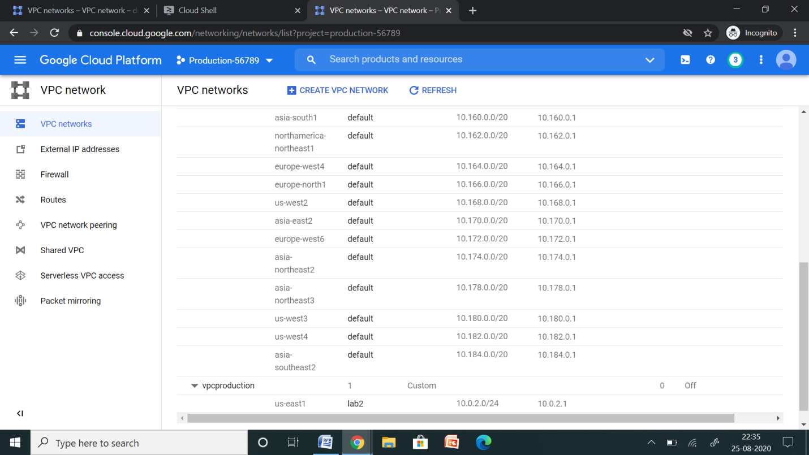

**VPC PEERING**

VPC Network 🡪 VPC Network Peering

Cloud VPC Network Peering lets you privately connect two VPC networks, which can reduce latency, cost, and increase security.

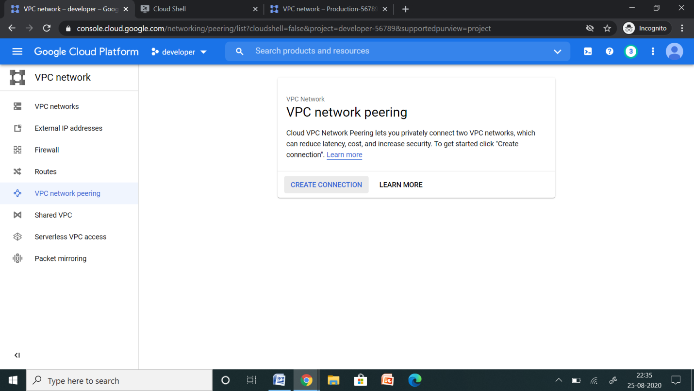

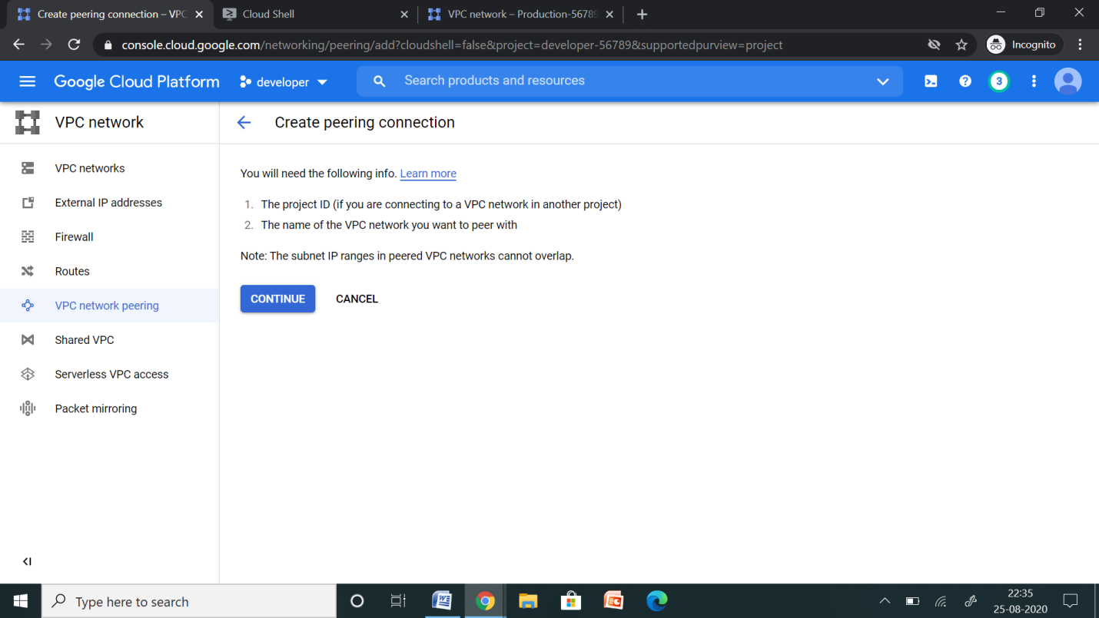

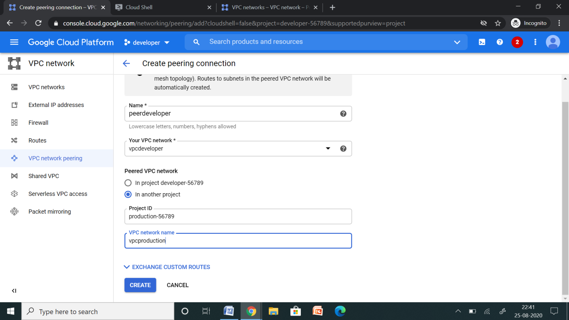

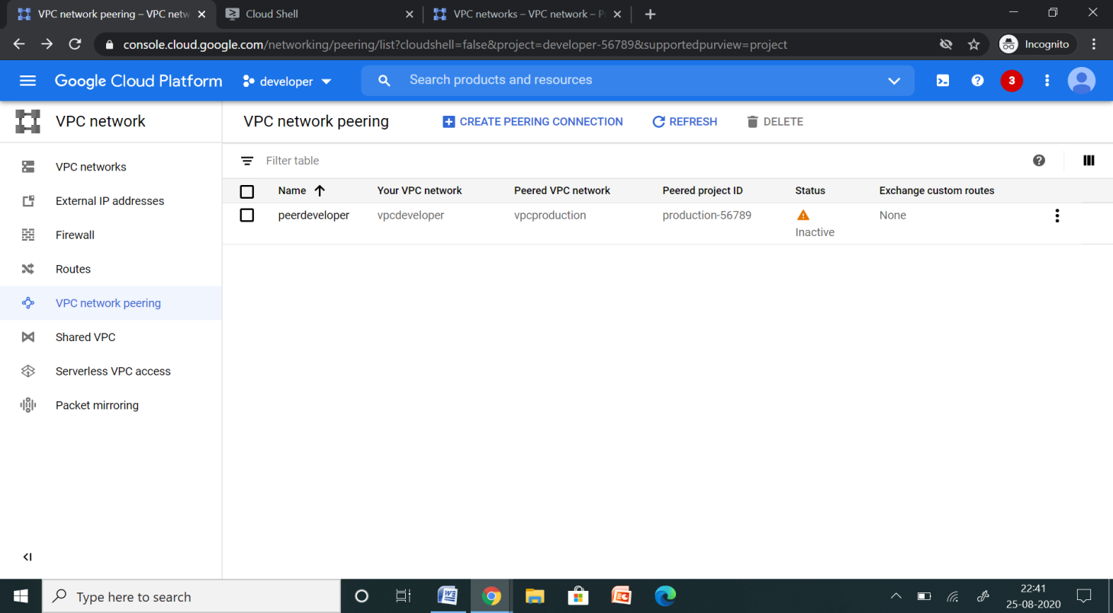

Here VPC Network Peering is inactive. This because on the other side there is no VPC peering. The moment you create peering the other side, it ill active automatically.

VPC Network Peering in other projects in different regions.

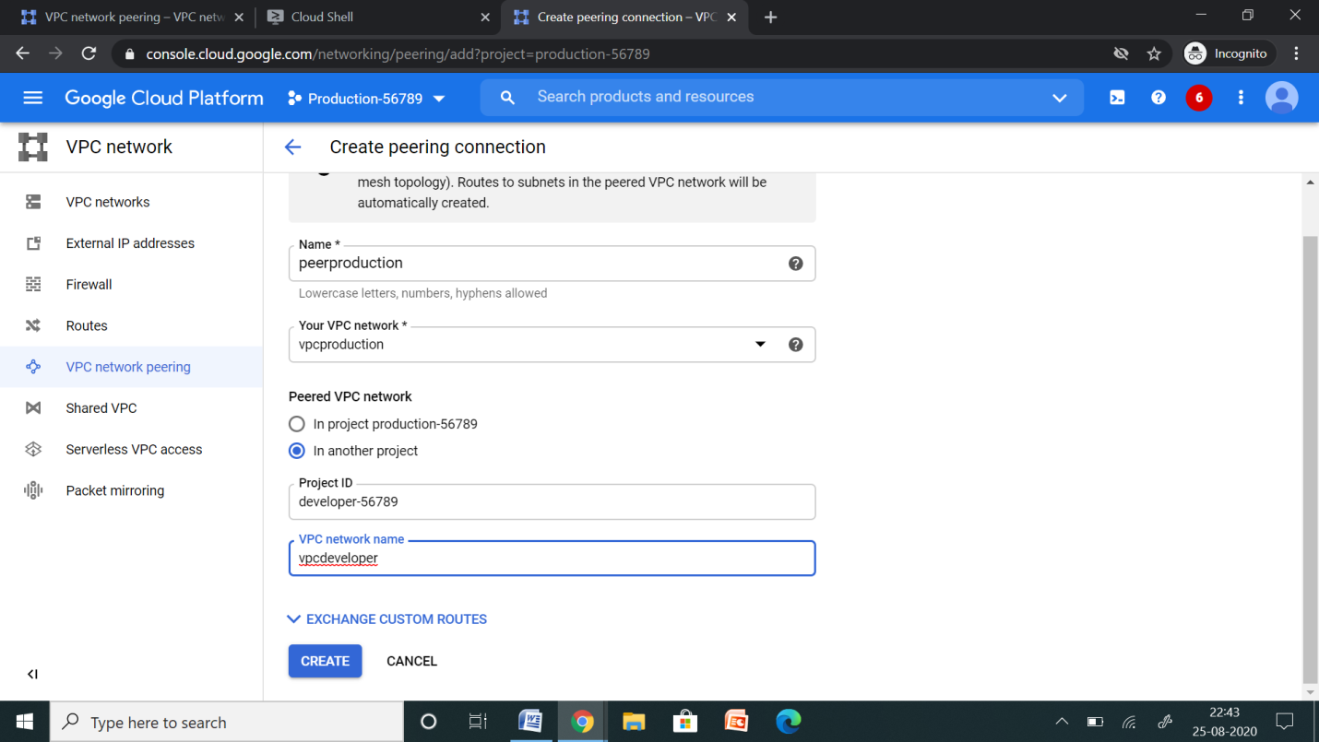

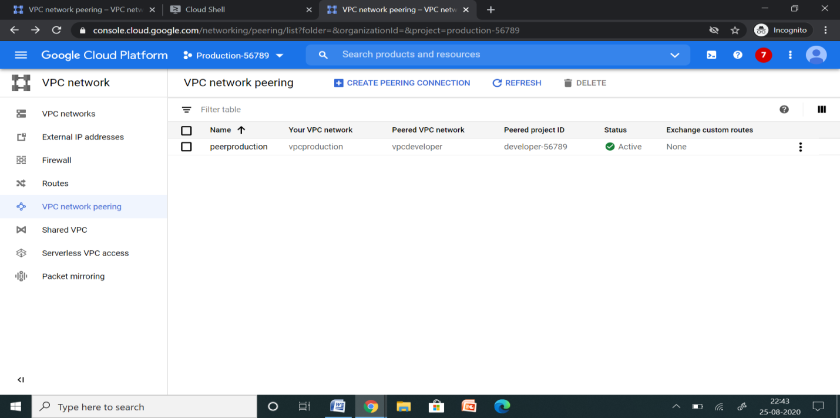

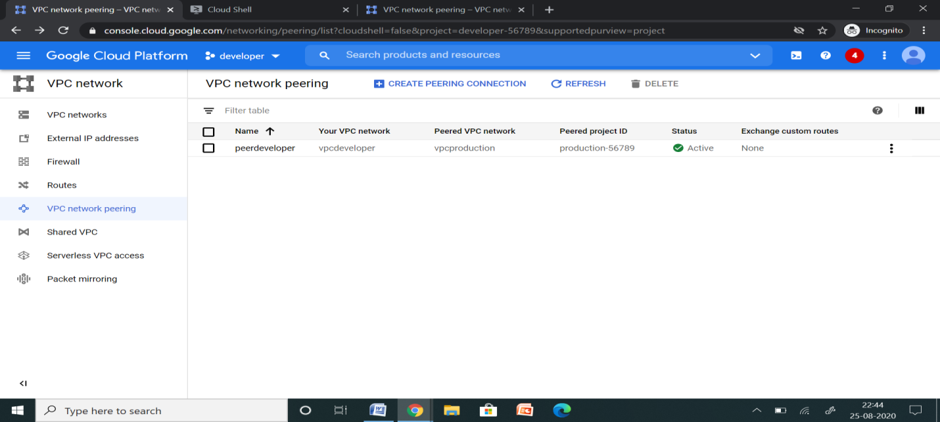

**SETUP GOOGLE CLOUD SDK IN BASEOS**

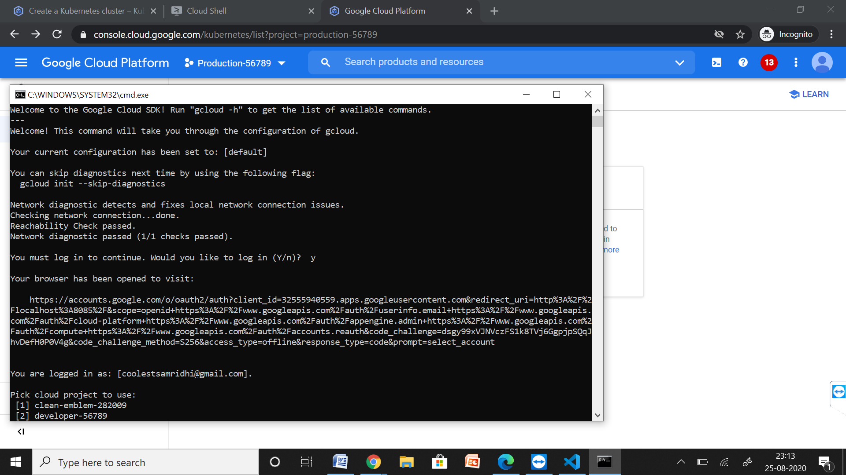

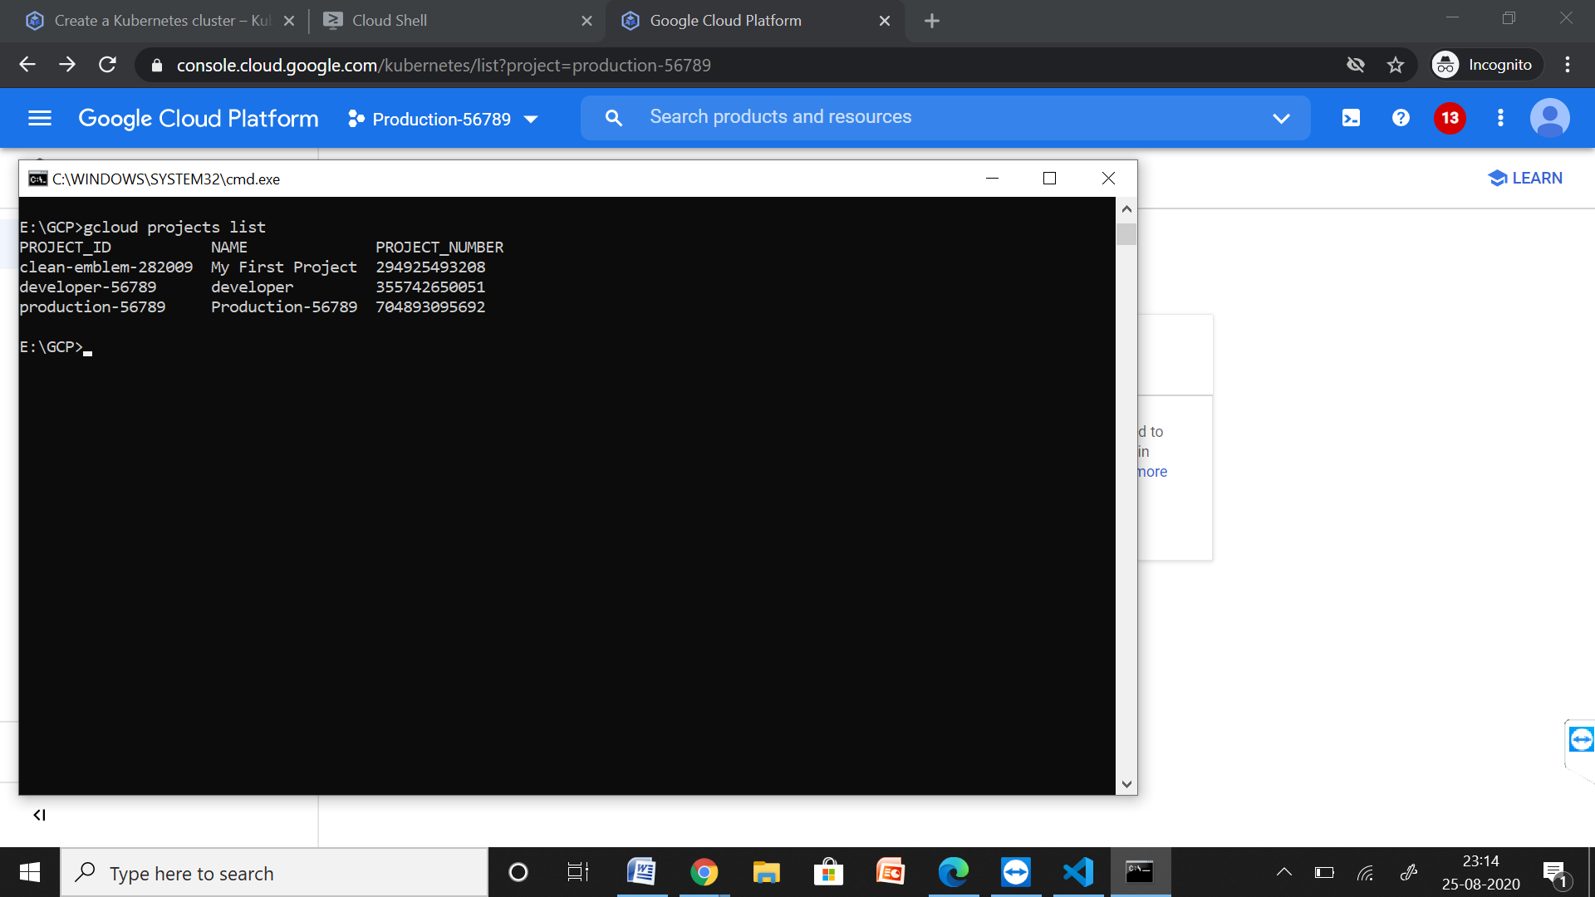

**CREATE KUBERNETES CLUSTER IN DEVELOPER PROJECT**

The next step is to deploy your WordPress container in the GKE cluster.

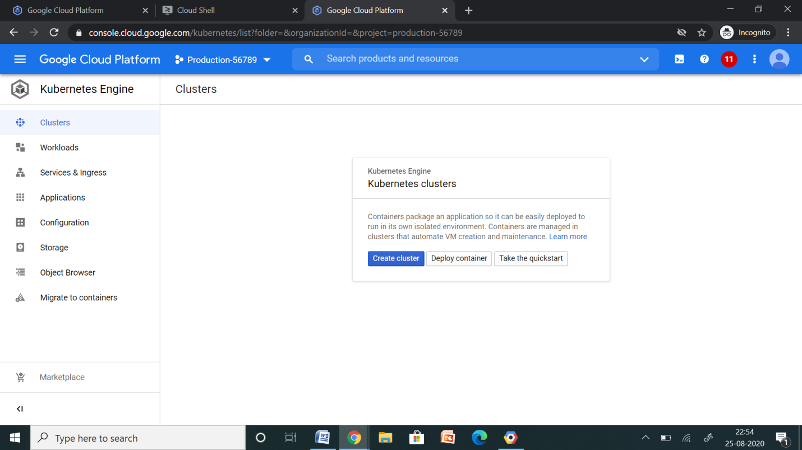

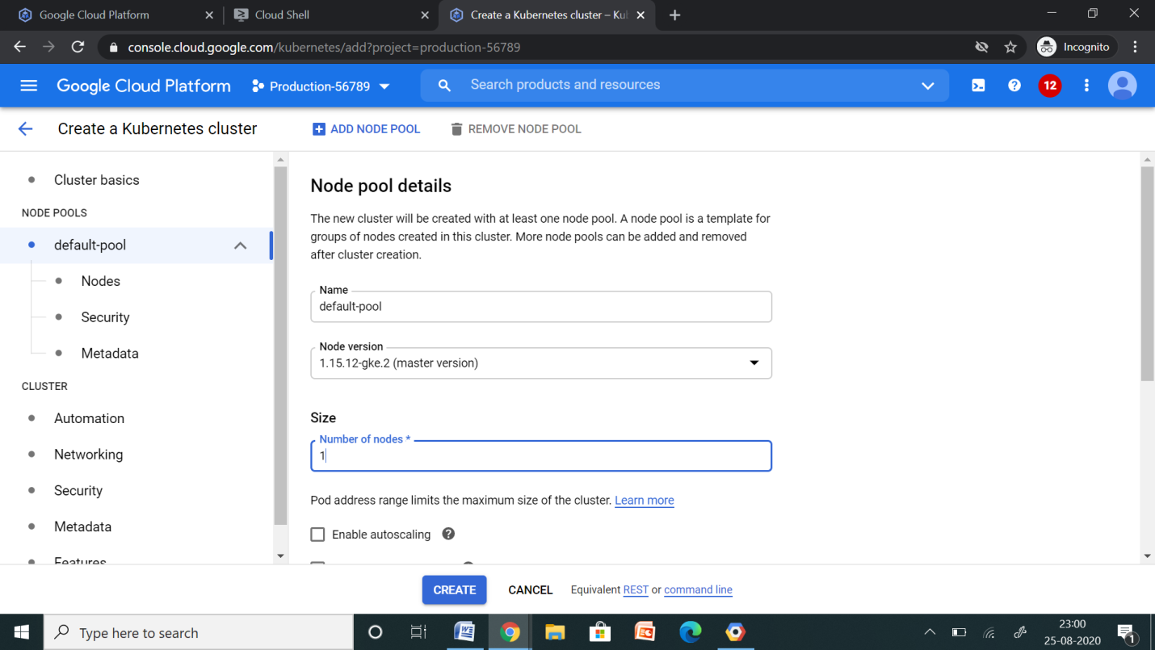

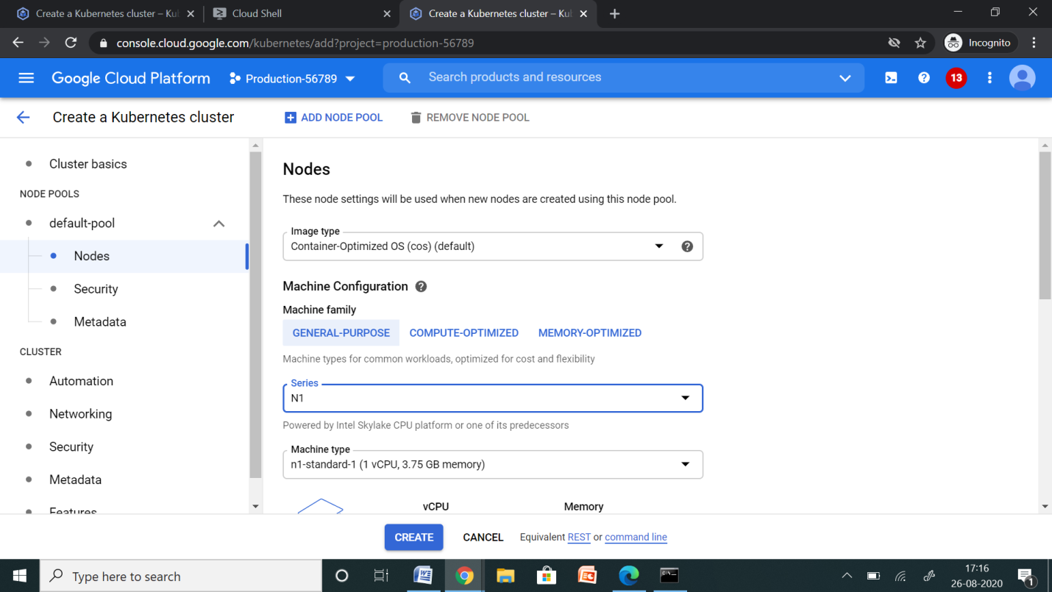

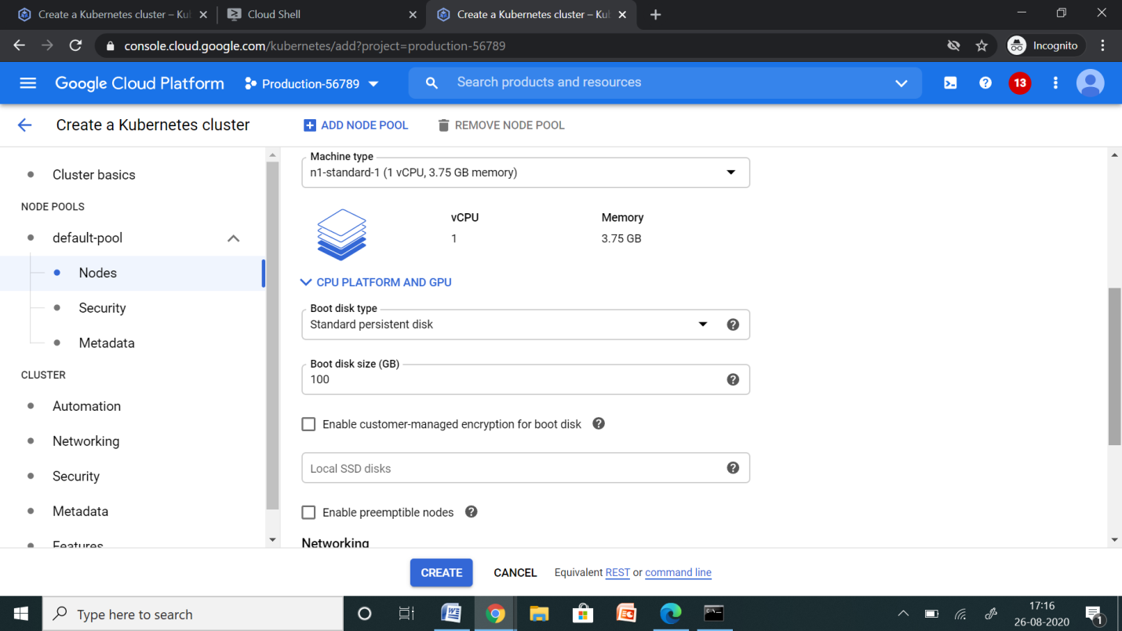

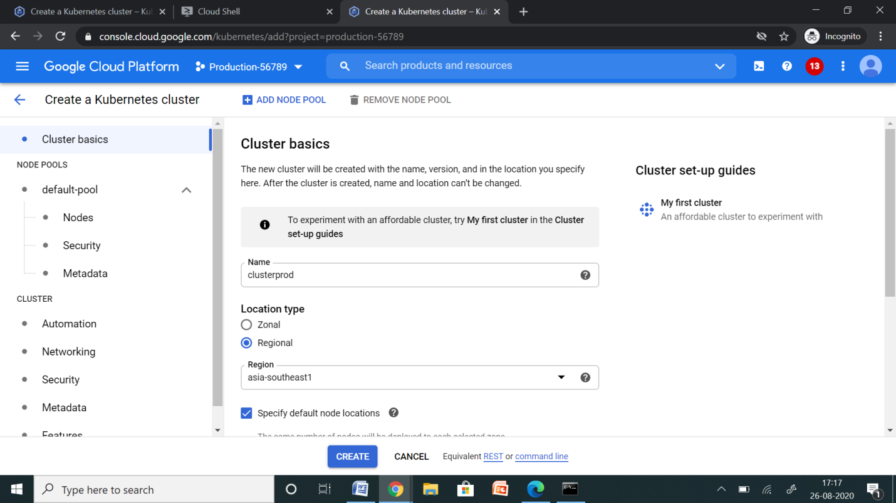

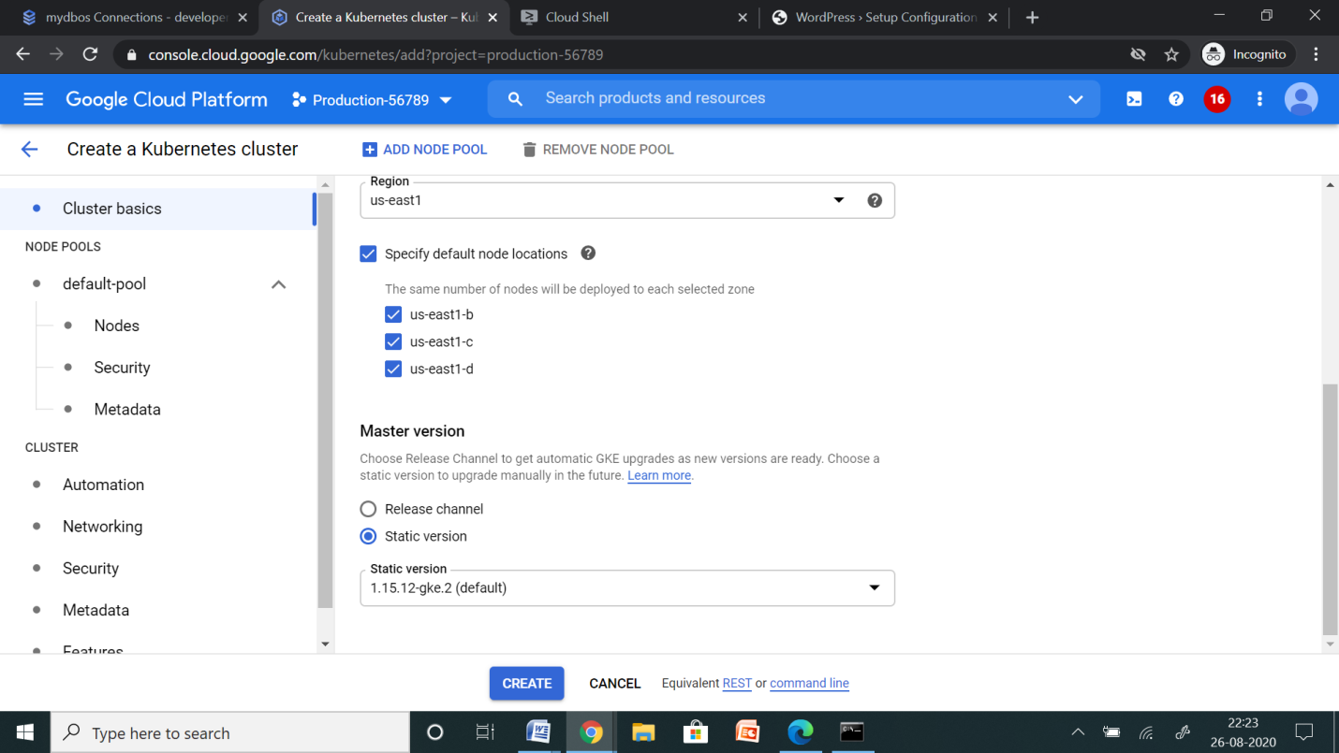

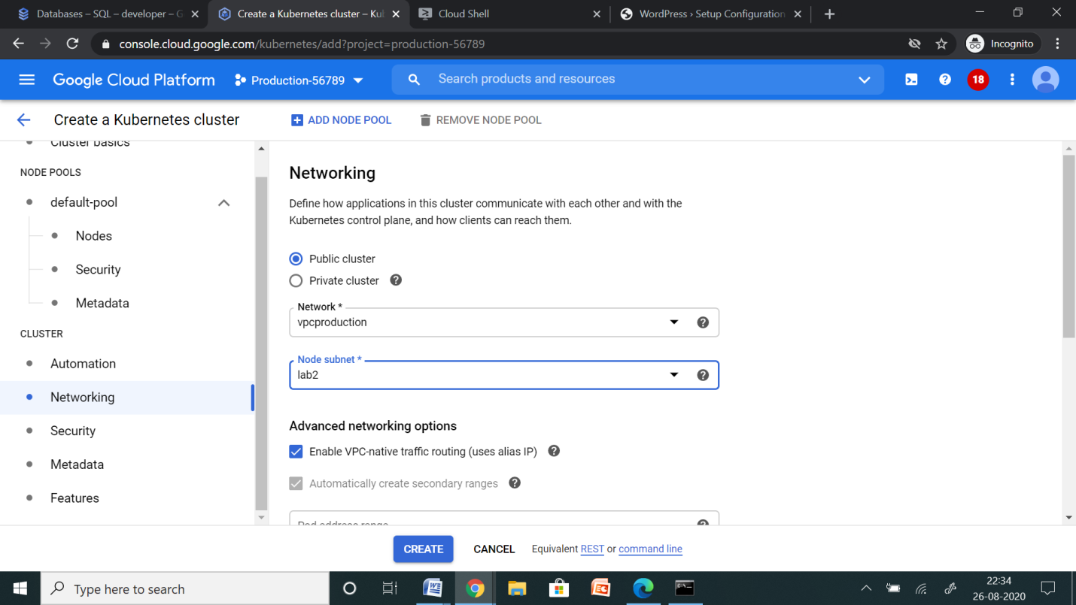

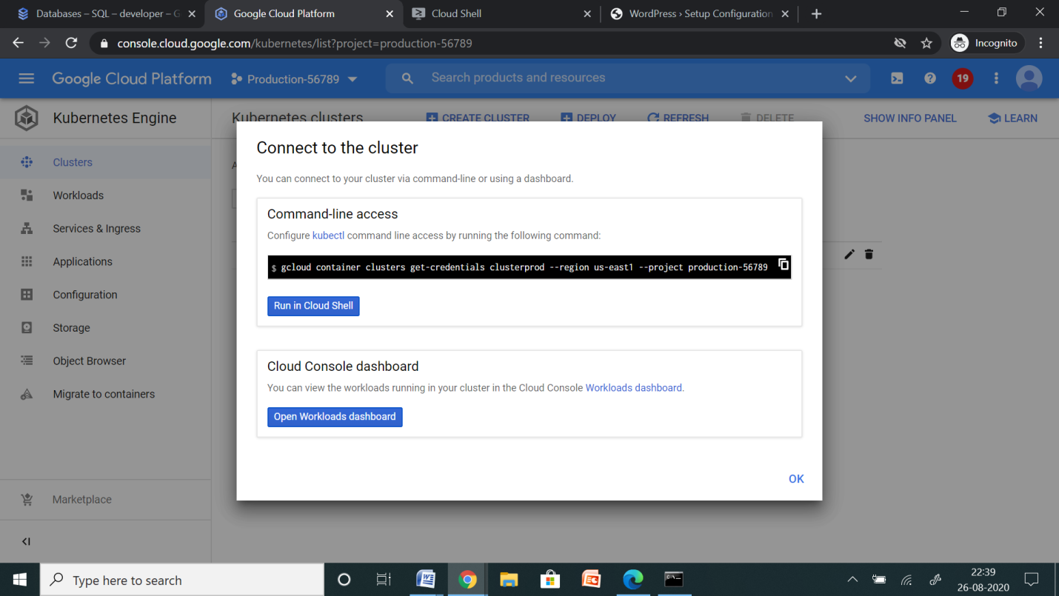

The cluster has been launched, now you need to connect to the cluster.

Copy the above command and paste in command prompt in your BaseOS.

**LAUNCH WORDPRESS APPLICATION WITH LOAD BALANCER**

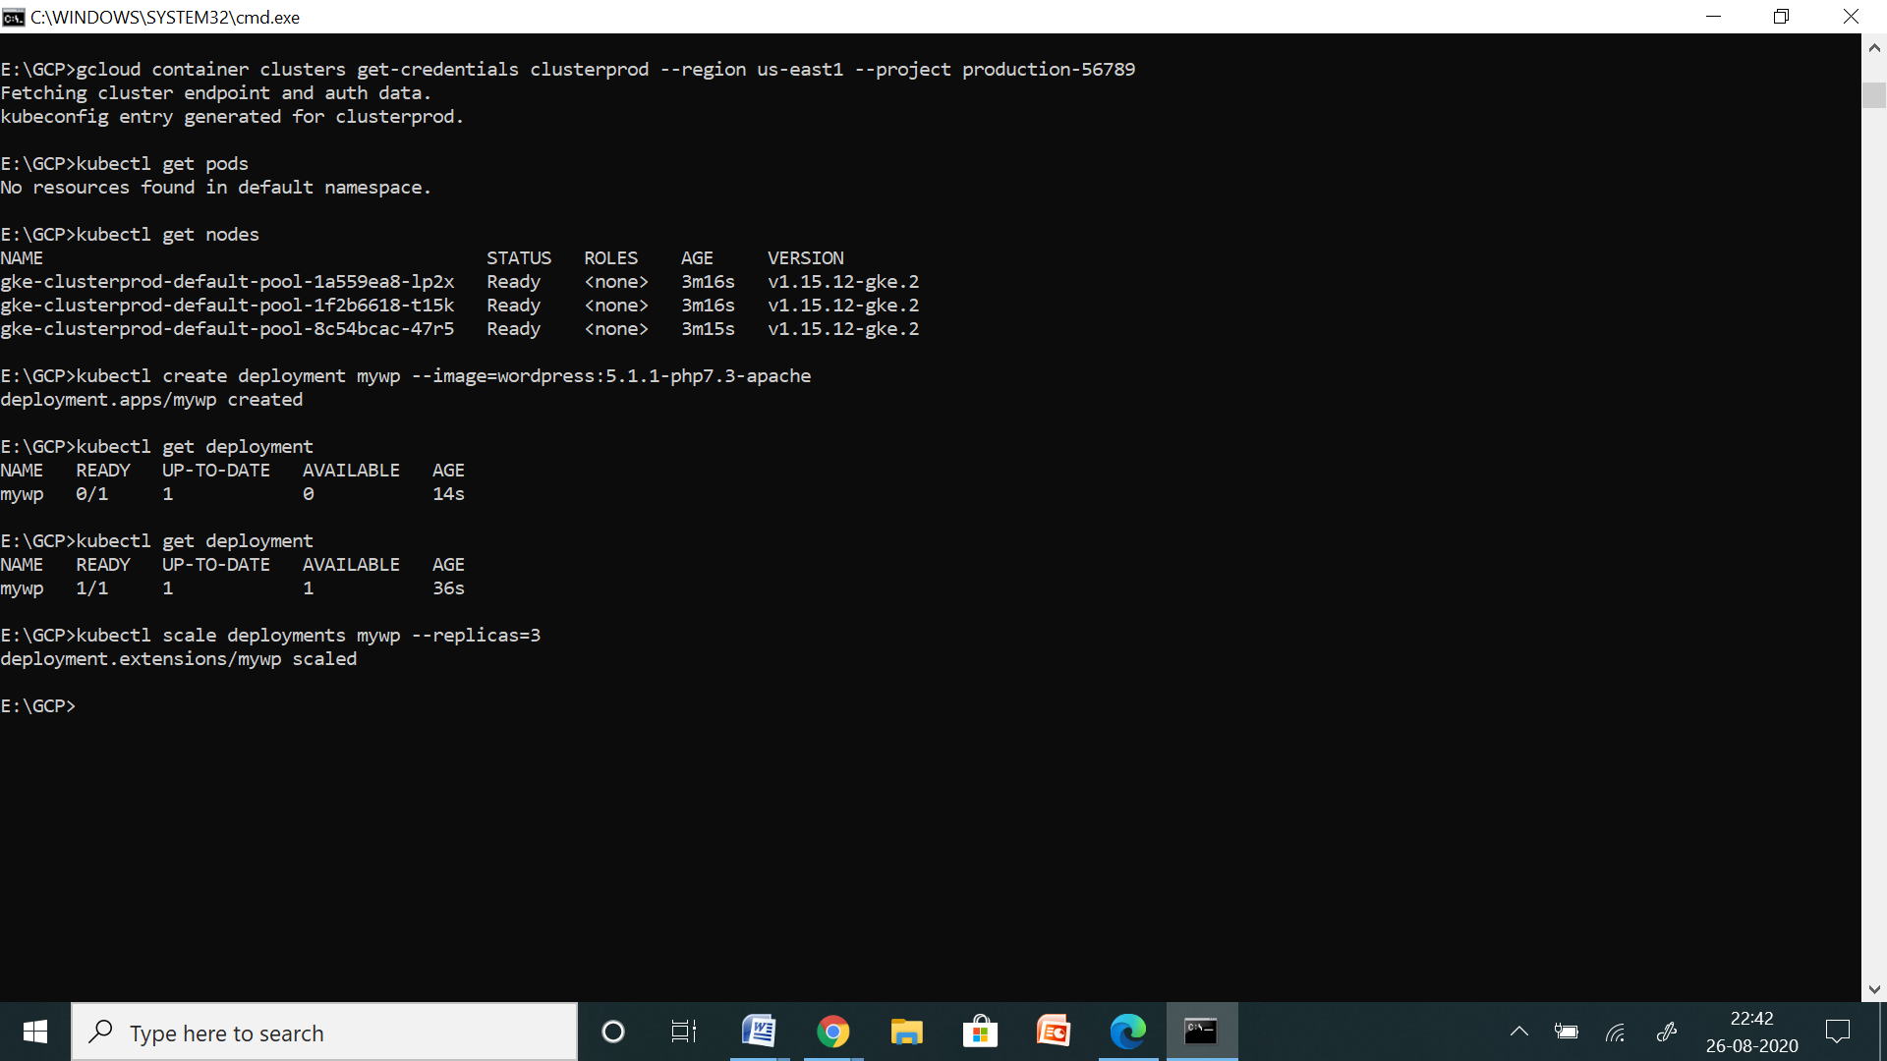

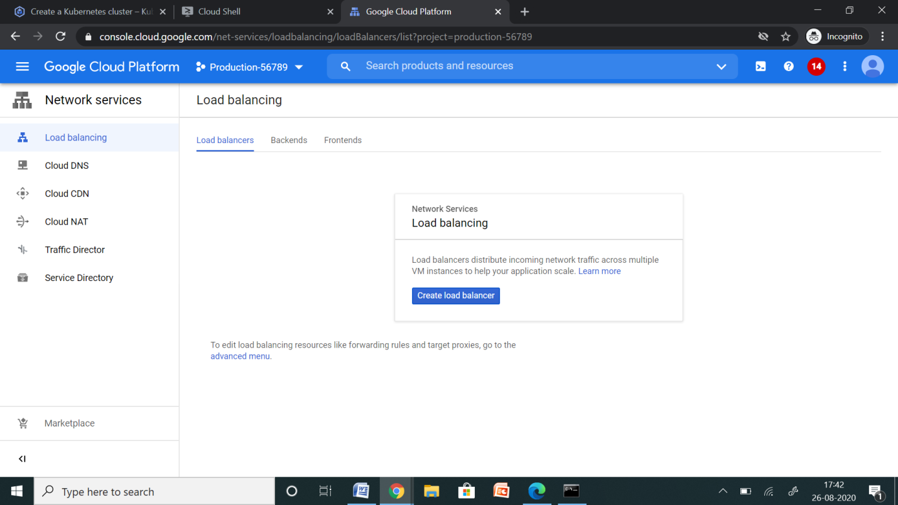

Note there is no load balancer created.

### Expose the WordPress service:

In the previous step, you deployed a WordPress container, but it's currently not accessible from outside your cluster because it doesn't have an external IP address. You can expose your WordPress app to traffic from the internet by creating and configuring a Kubernetes Service [with an attached external load balancer](https://cloud.google.com/kubernetes-engine/docs/concepts/network-overview).

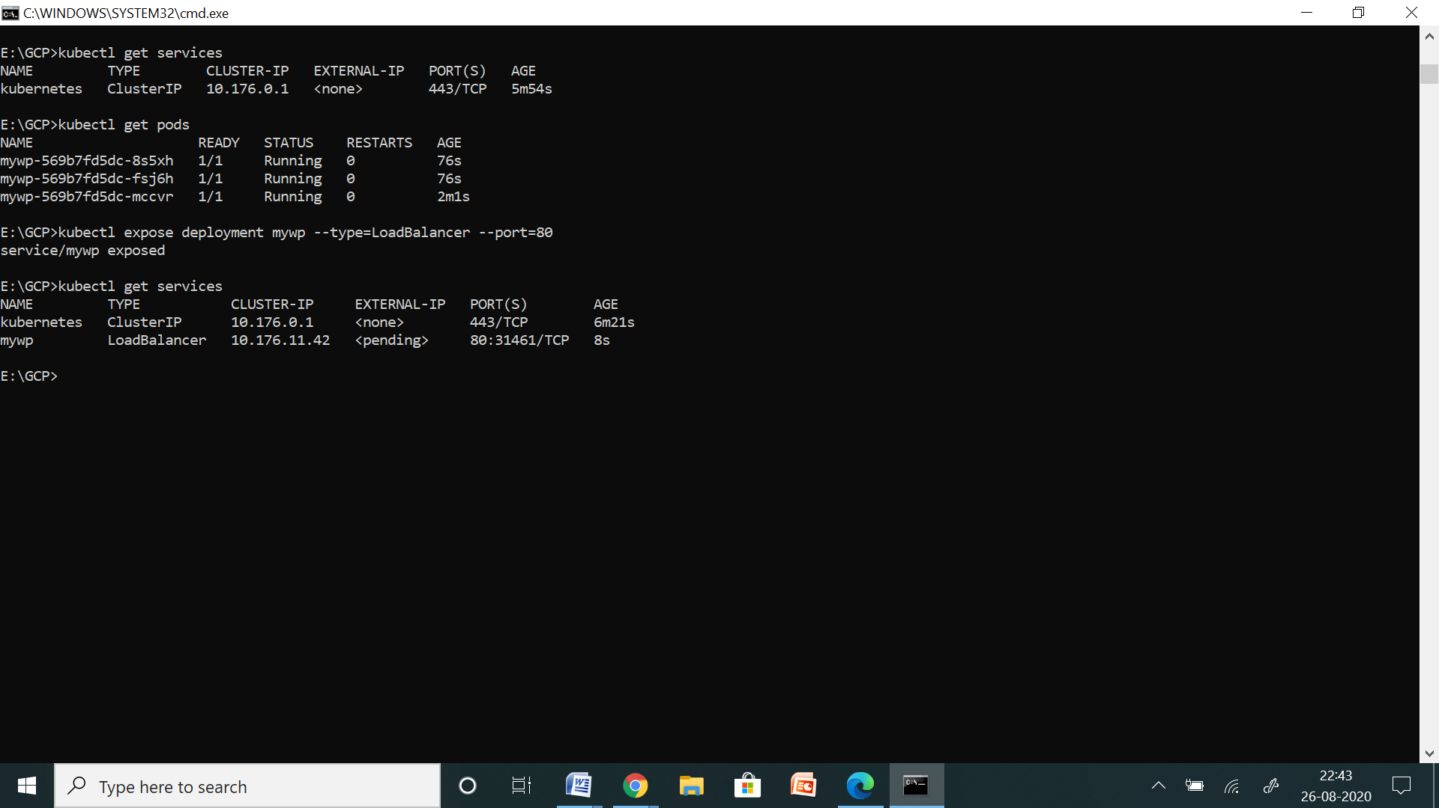

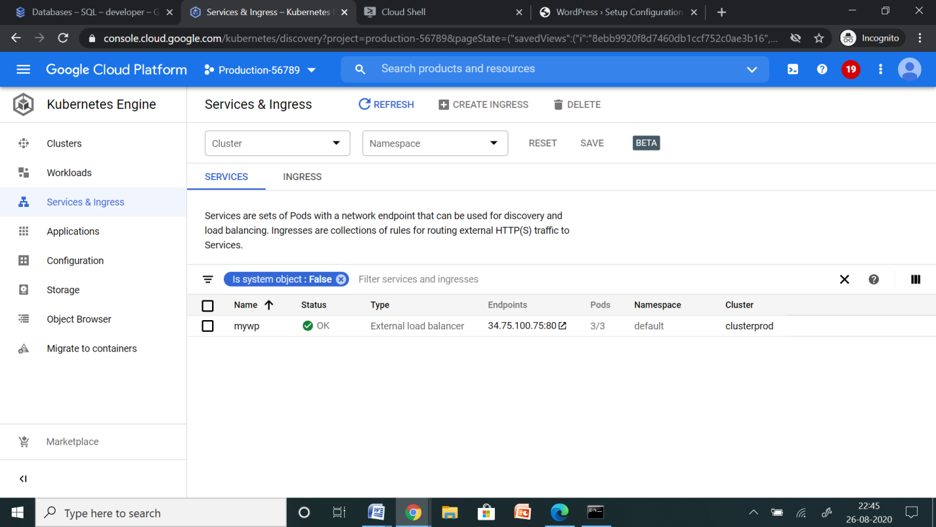

Automatically, a load balancer has been created.

Now using the URL, open the WordPress application.

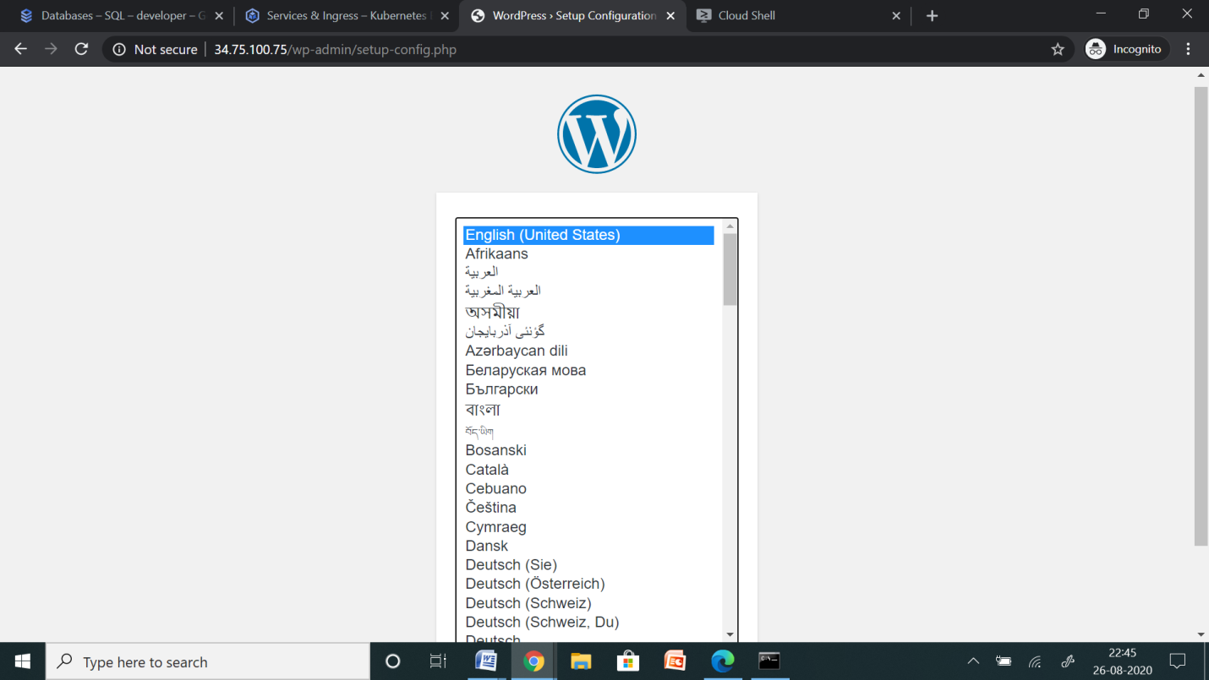

**CREATE SQL SERVER IN THE PRODUCTION PROJECT**

SQL 🡪Create Instance

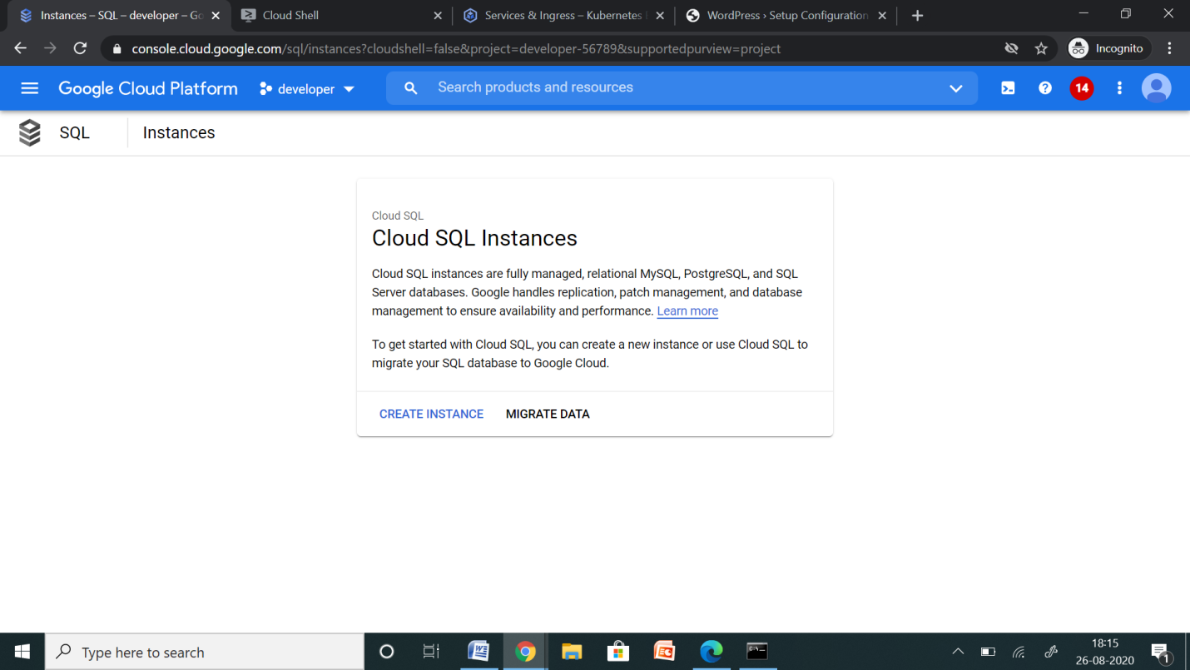

* Choose MYSQL

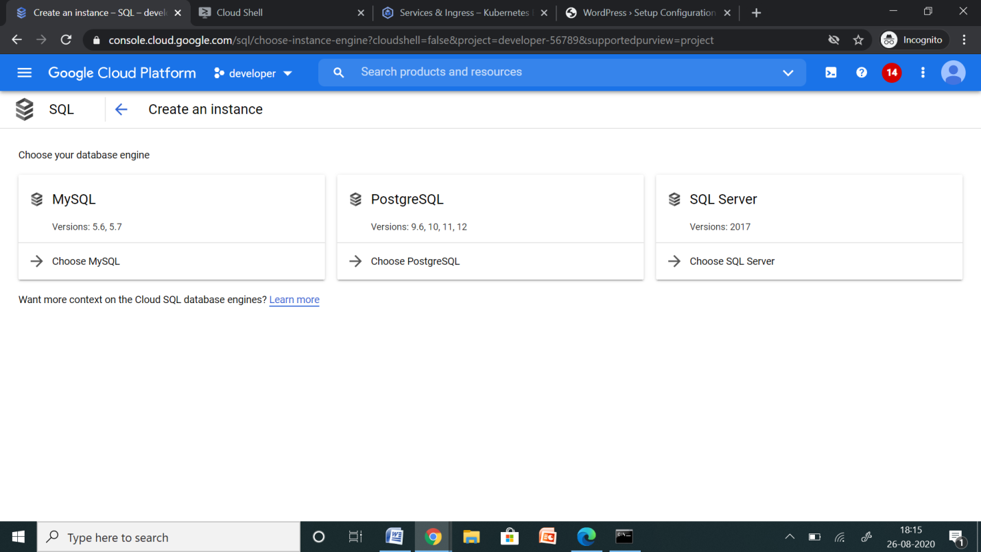

Create an instance named mydbos in the selected region.

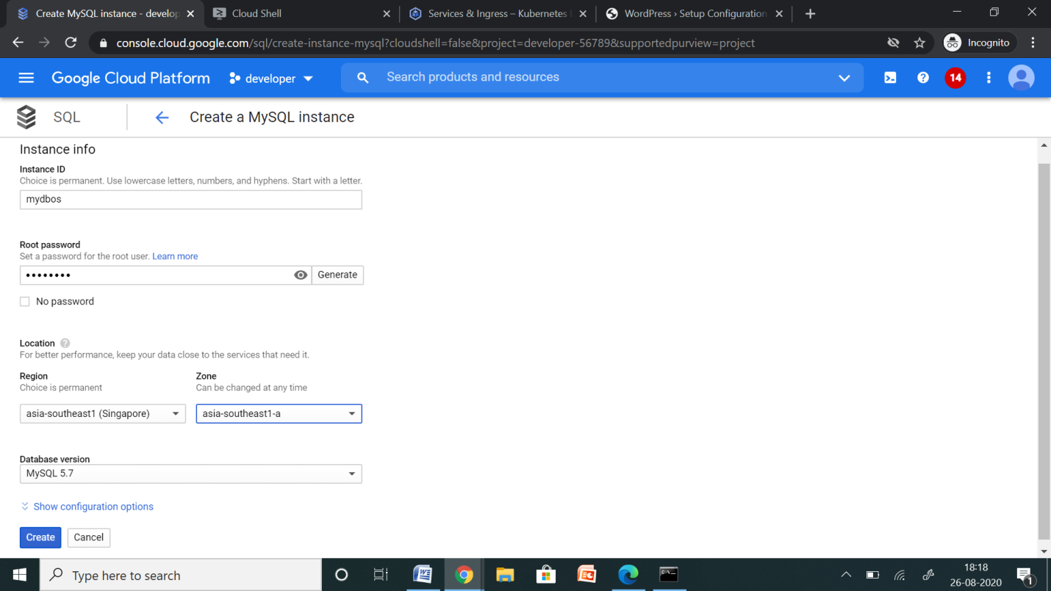

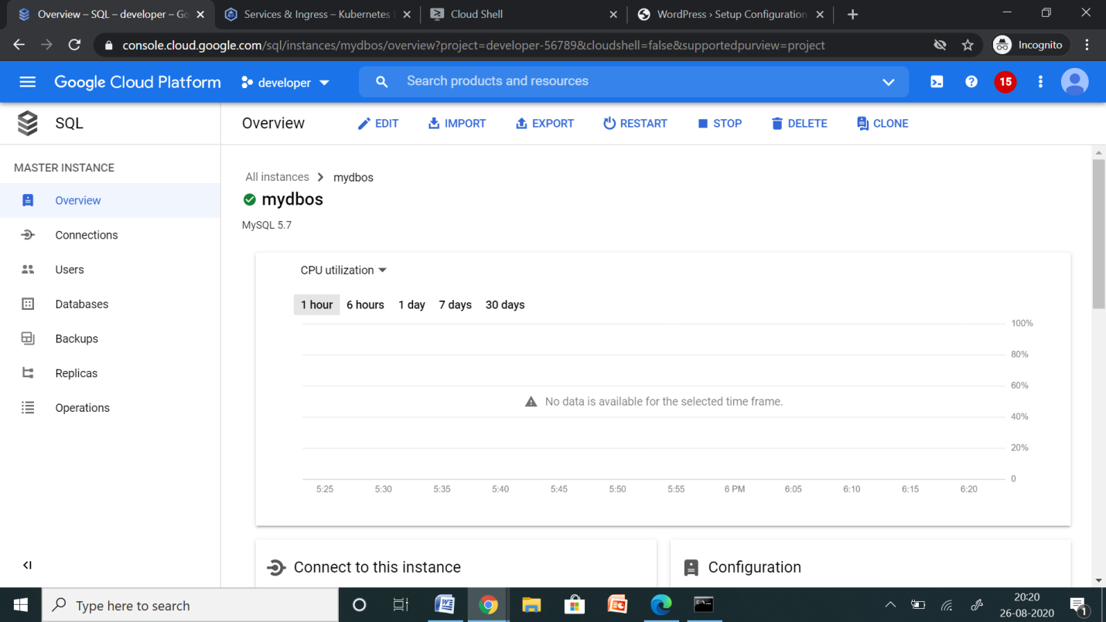

Now login to MySQL server using username and password.

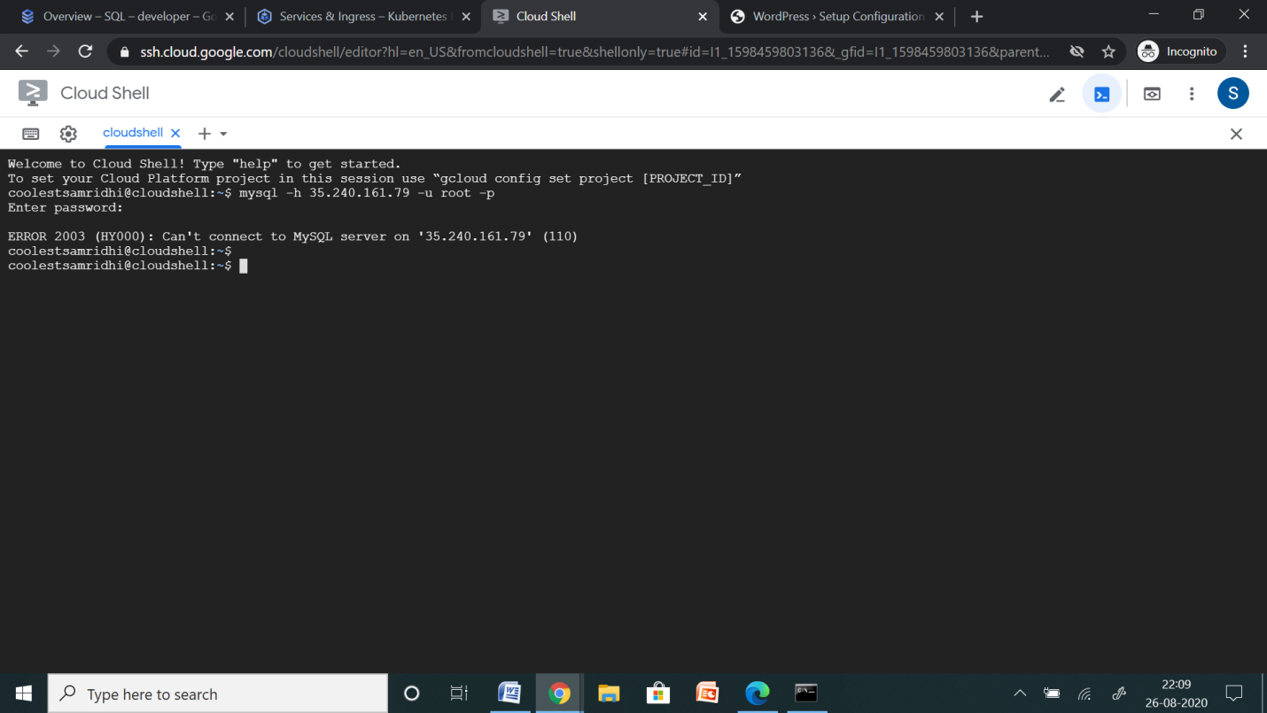

This fails because of the network firewall which does not allow you to log in to your instance.

SQL 🡪 Overview 🡪 Edit

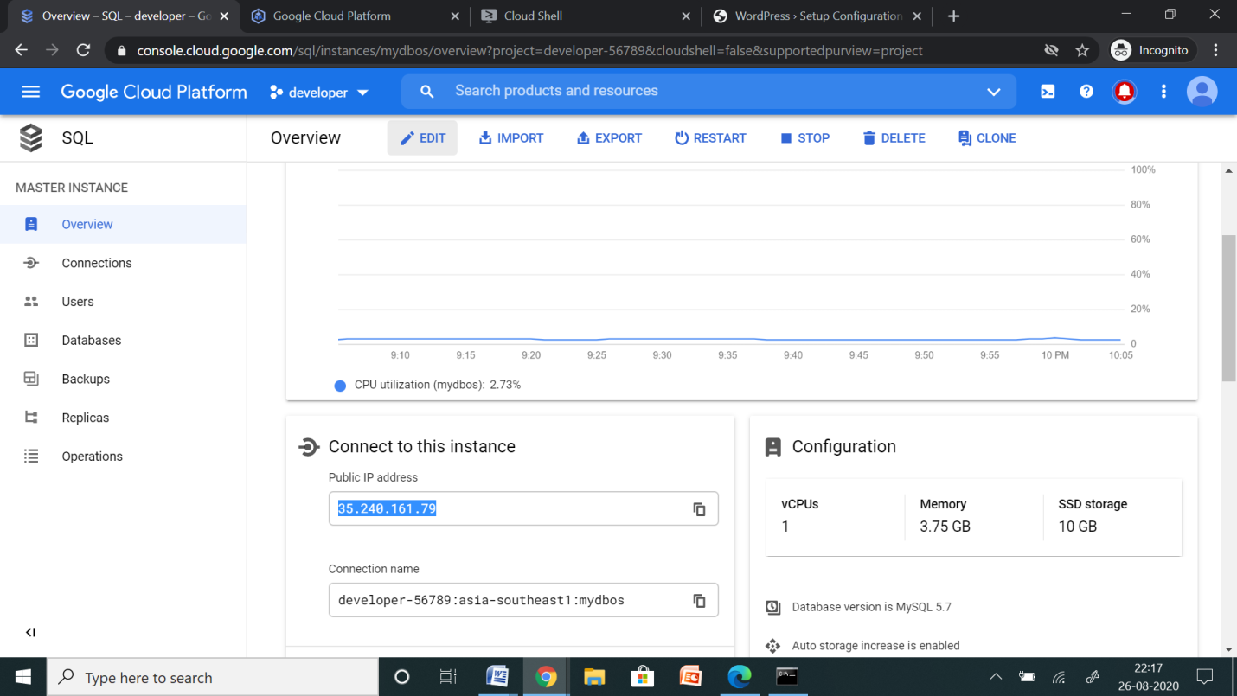

Add network which allows any IPv4 client to pass the network firewall and make login attempts to your instance.

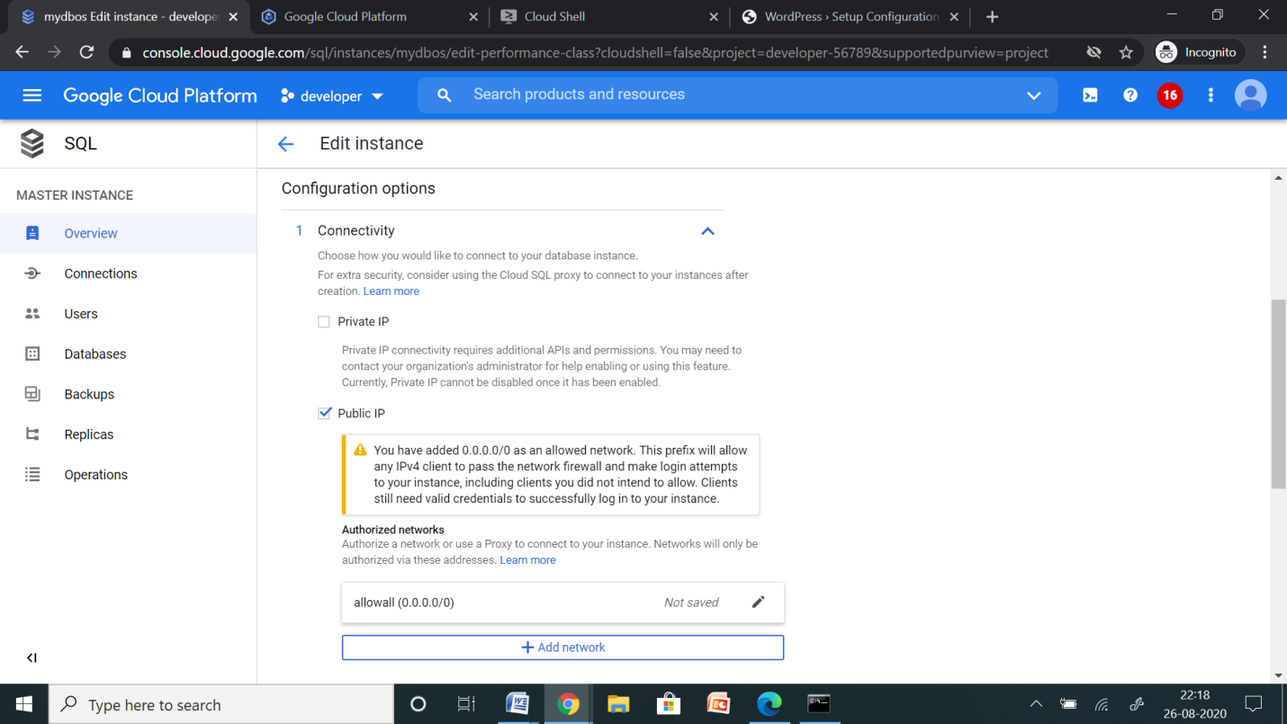

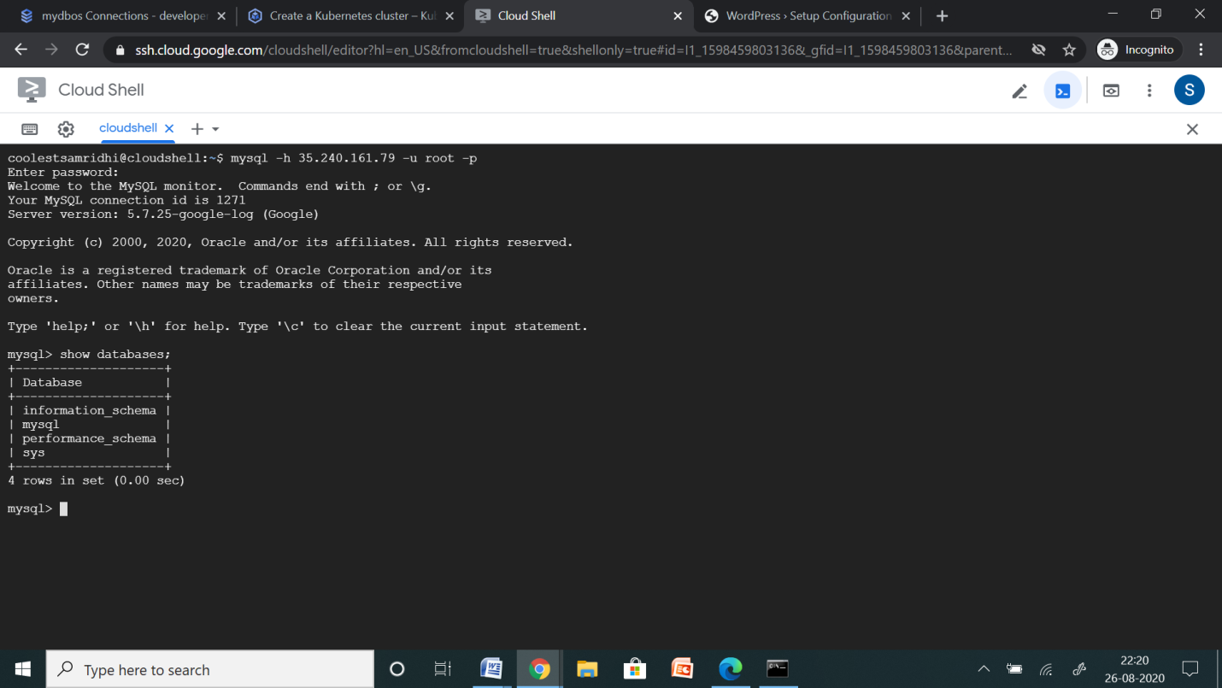

Now you are successfully able to log in to MySQL server.

**CREATE DATABASE NAMED DBPROD**

Now create a new Database in this instance.

SQL 🡪 Databases 🡪 Create Database

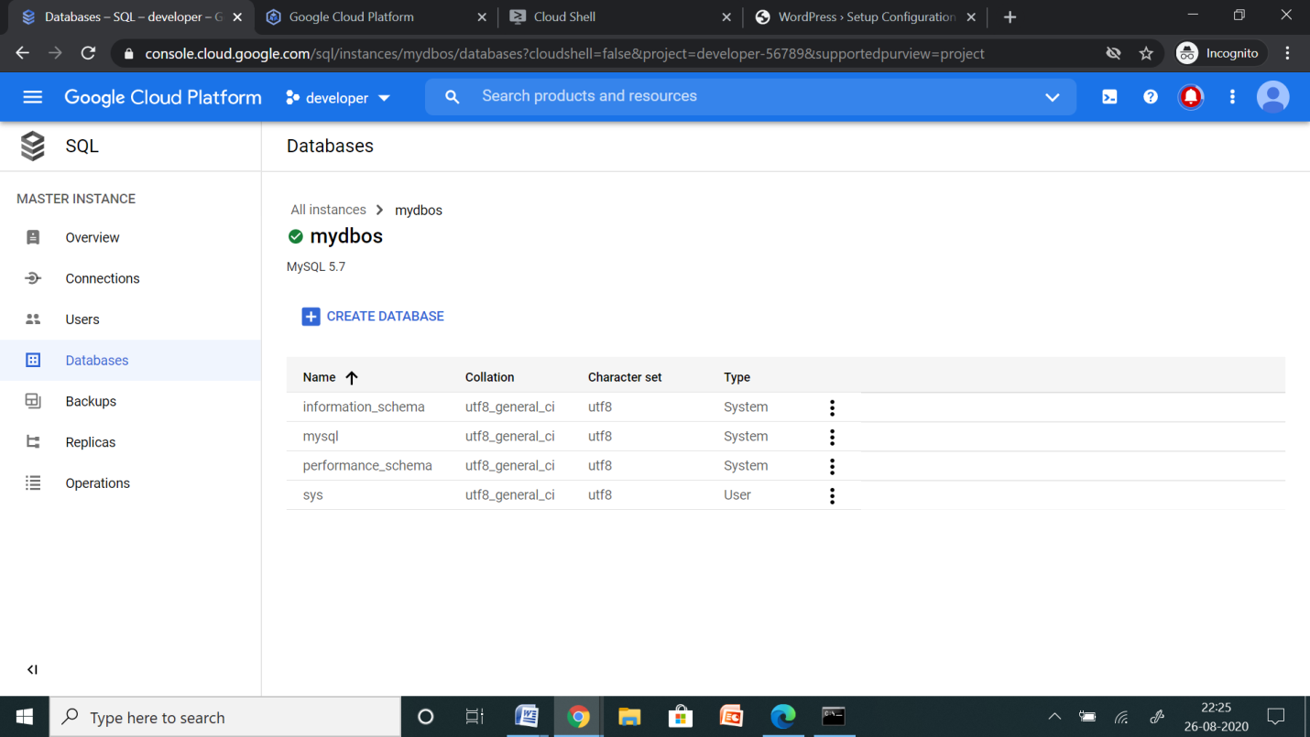

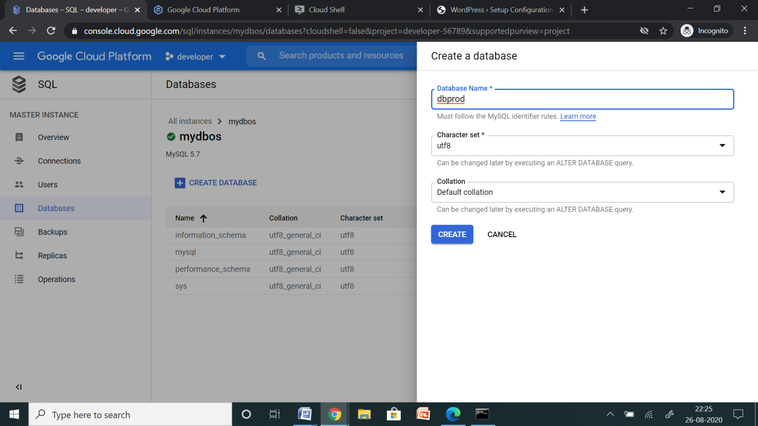

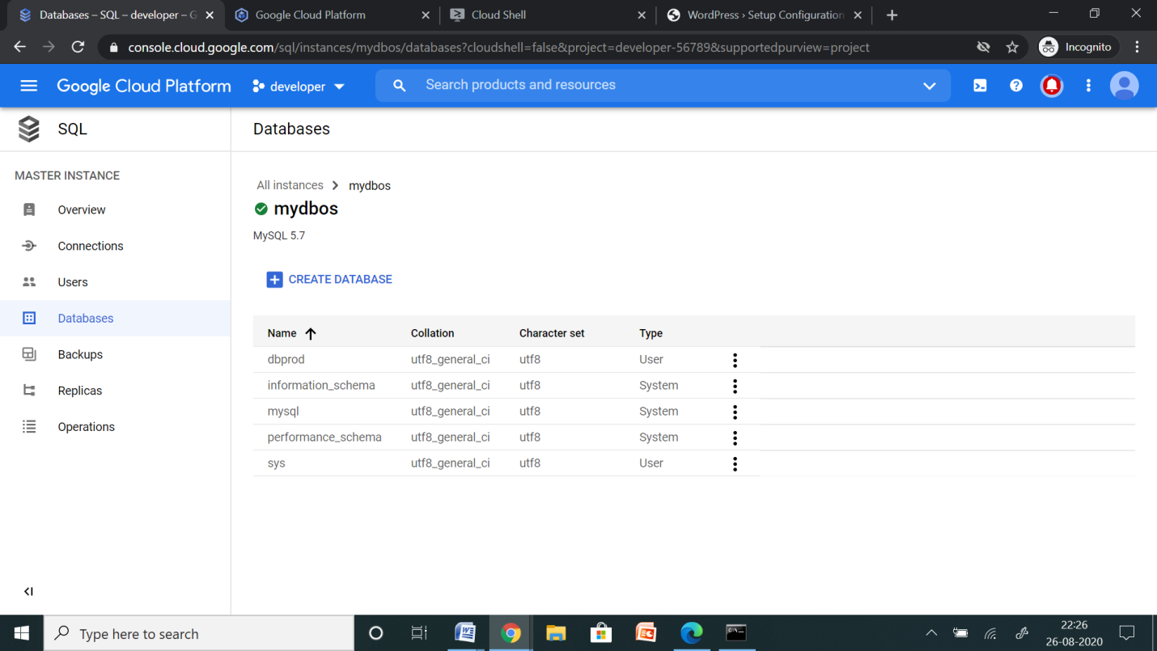

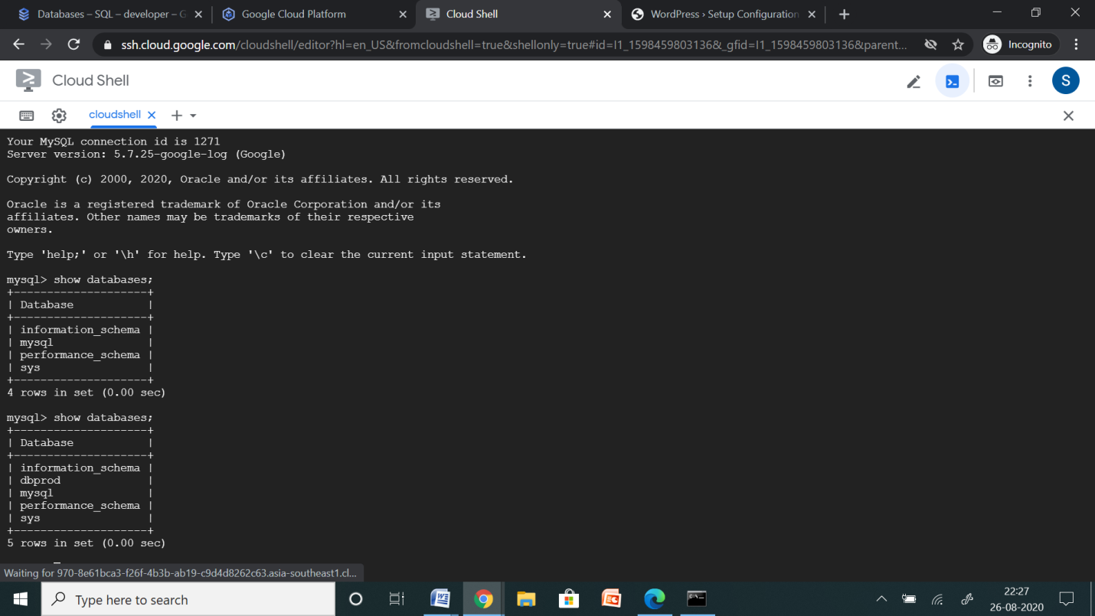

**CONNECT THE SQL DATABASE TO THE WORDPRESS APPLICATION LAUNCHED IN THE KUBERNETES CLUSTER**

In this section, you set up your WordPress blog.

1. In your browser, go to the following URL, replacing external-ip-address with the EXTERNAL_IP address of the service that exposes your WordPress instance:
2. On the WordPress installation page, select a language, and then click Continue.
3. Complete the Information needed page, and then click Install WordPress.
4. Click Log In.
5. Enter the username and password that you previously created.

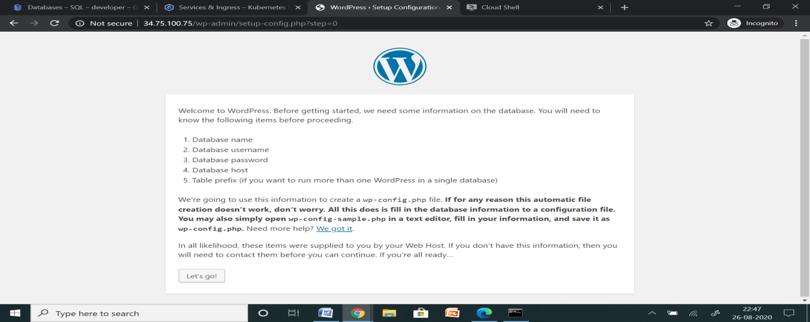

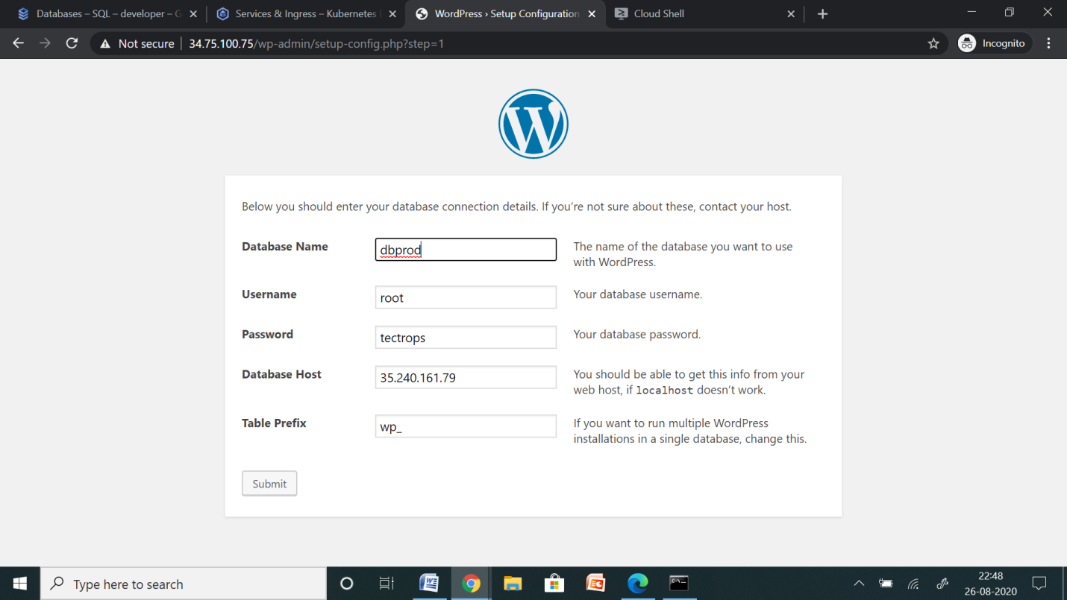

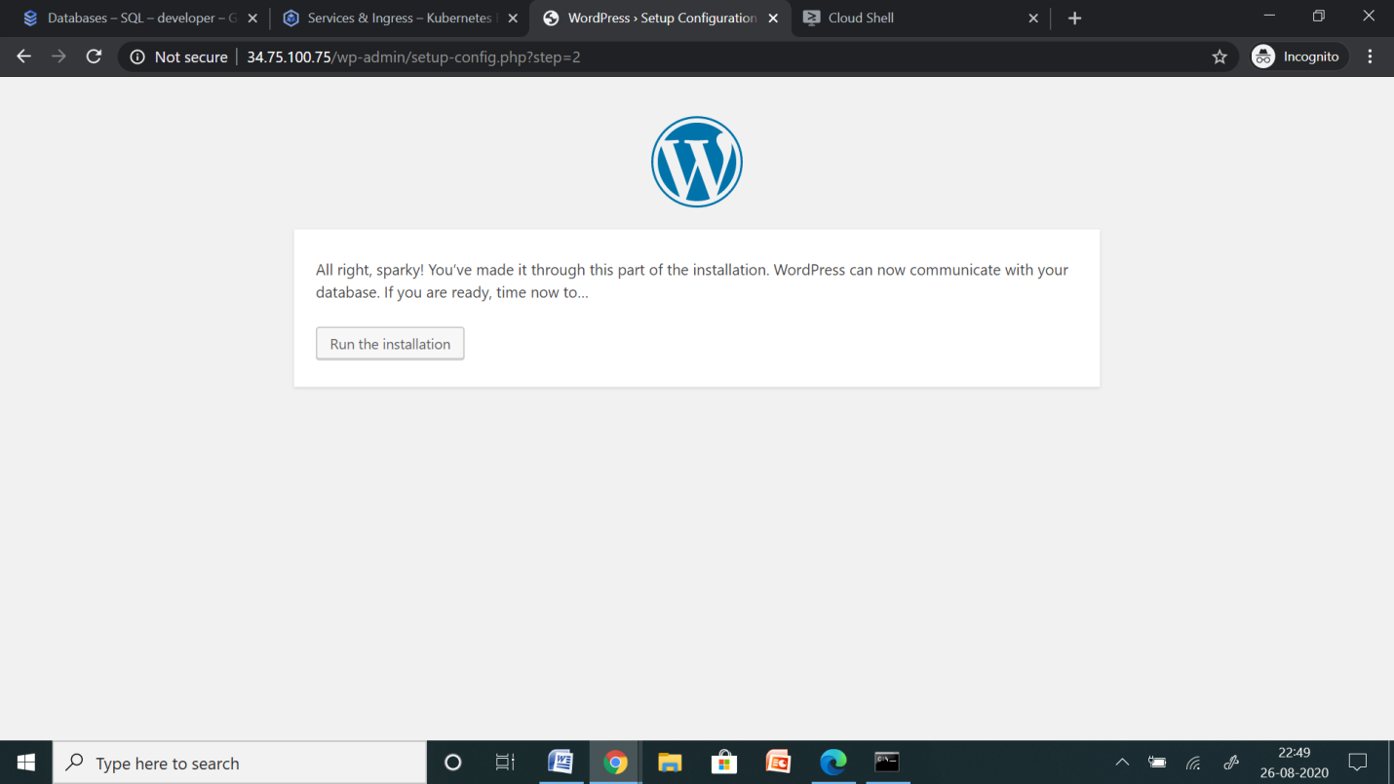

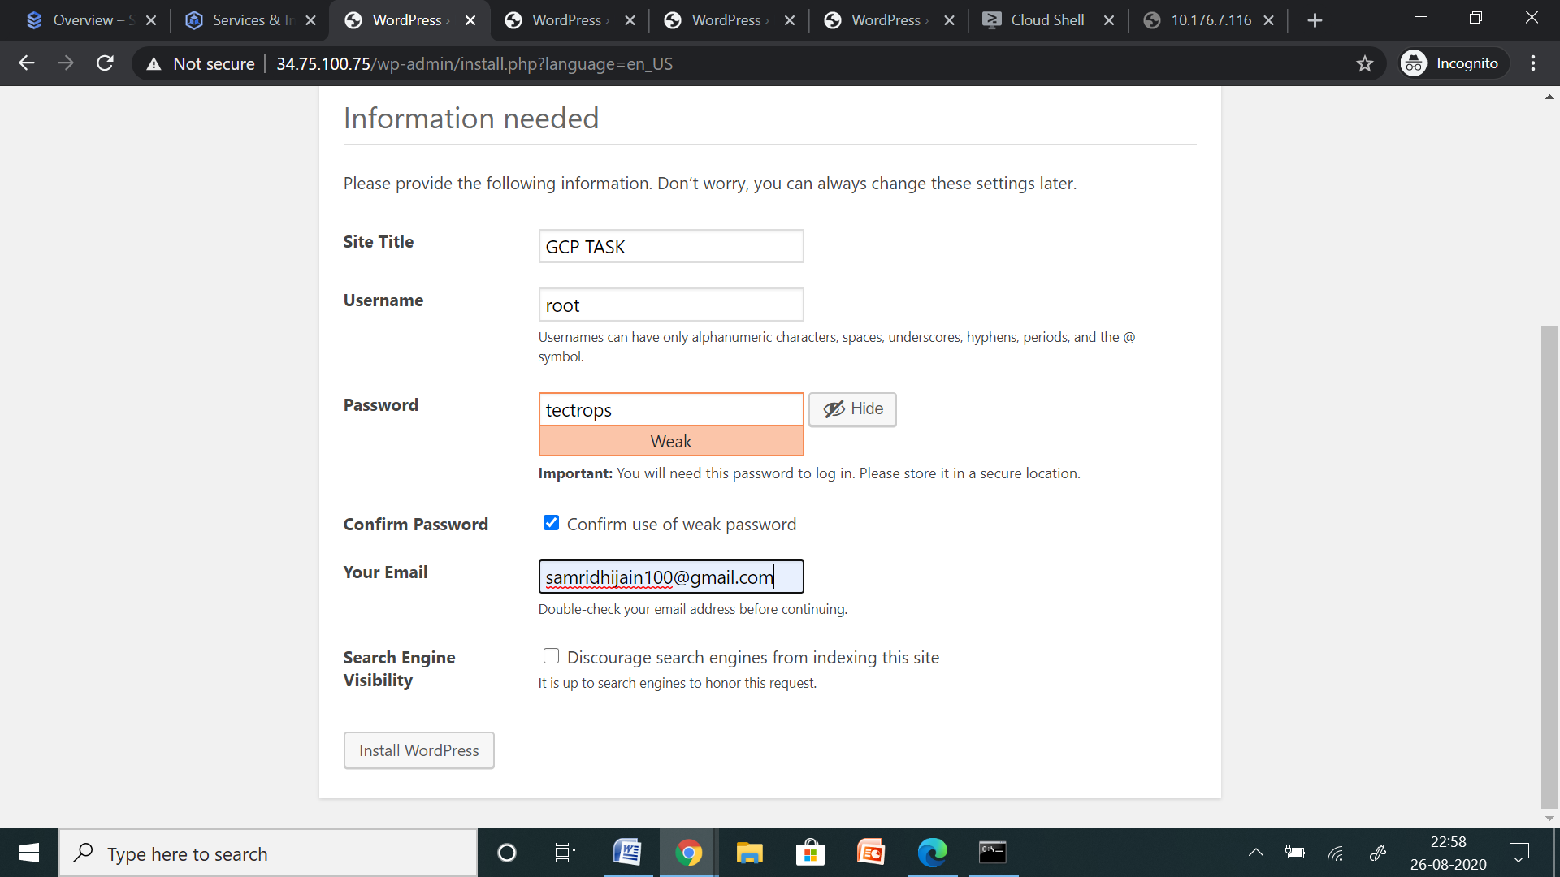

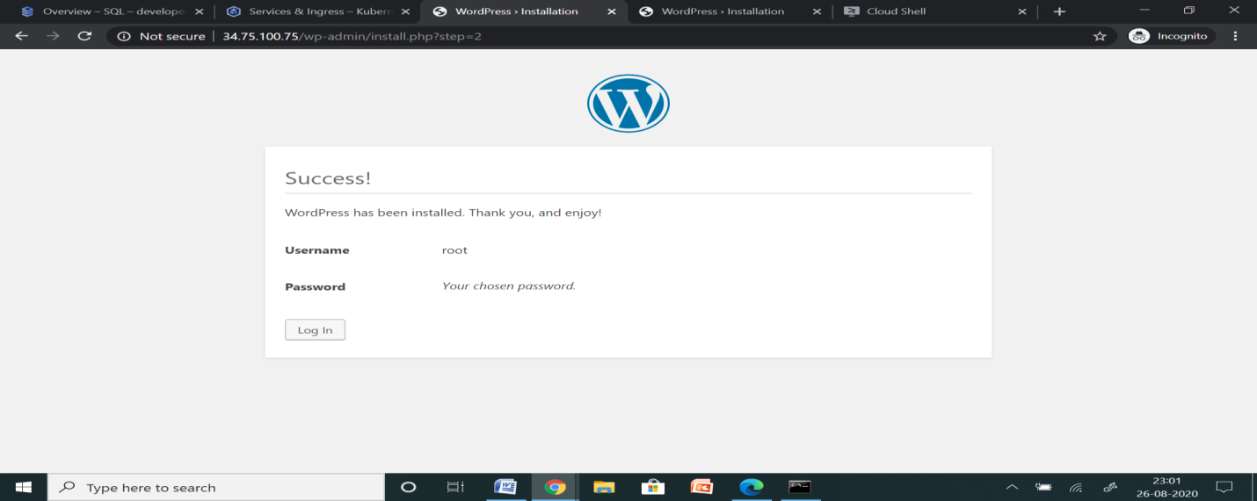

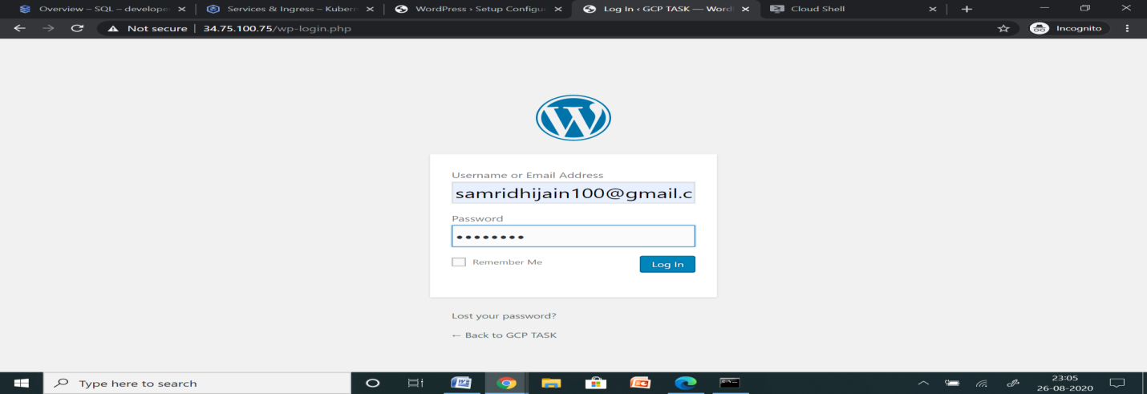

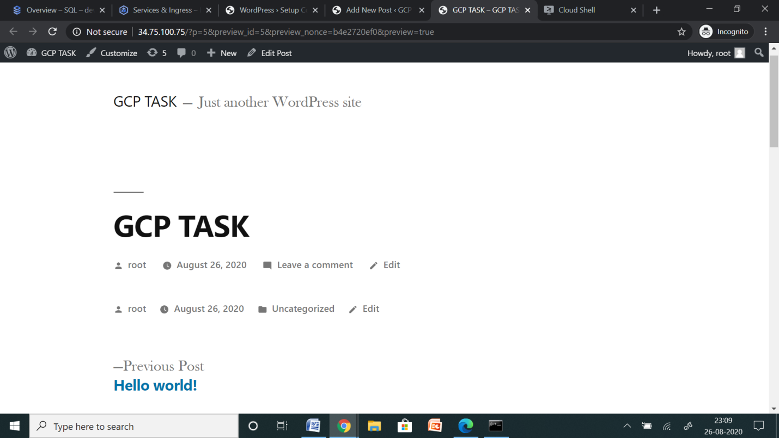

So finally, I have successfully deployed WordPress on GKE and Cloud SQL in different VPC on GCP.